

**COMSATS University Islamabad (CUI)**

**Estate Wizards**

***By***

**Sharjeel Nasir CIIT/FA17-BCS-001/ISB**

**Inshal Aamir CIIT/FA17-BCS-032/ISB**

**Muhammad Ghazi ud-din Butt CIIT/FA17-BCS-048/ISB**

***Supervisor*Ma’am Sadia Maryam**

***Bachelor of Science in Computer Science (2017-2021)***

**The candidate confirms that the work submitted is their own and appropriate  
 credit has been given where reference has been made to the work of others**.



**COMSATS University Islamabad (CUI)**

**Estate Wizards**

**A project presented to**

**COMSATS University Islamabad**

**In partial fulfillment**

**of the requirement for the degree of**

***Bachelor of Science in Computer Science (2017-2021)***

**By**

**Sharjeel Nasir CIIT/FA17-BCS-001/ISB**

**Inshal Aamir CIIT/FA17-BCS-032/ISB**

**Muhammad Ghazi ud-din Butt CIIT/FA17-BCS-048/ISB**

**DECLARATION**

We hereby declare that this software, neither whole nor as a part has been copied out from any source. It is further declared that we have developed this software and accompanied report entirely on the basis of our personal efforts. If any part of this project is proved to be copied out from any source or found to be reproduction of some other. We will stand by the consequences. No Portion of the work presented has been submitted of any application for any other degree or qualification of this or any other university or institute of learning.

|  |  |  |
| --- | --- | --- |
| Sharjeel Nasir | Inshal Aamir | Muhammad Ghazi ud-din Butt |
| --------------------------- | --------------------------- | --------------------------- |

**CERTIFICATE OF APPROVAL**

It is to certify that the final year project of BS (CS) “Estate Wizards” was developed by   
**Sharjeel Nasir (CIIT/FA17-BCS-001), Inshal Aamir(CIIT/FA17-BCS-032)** and **Muhammad Ghazi ud-din Butt (CIIT/FA17-BCS-048)** under the supervision of “Ma’am Sadia Maryam” and co supervisor “CO-SUPERVISOR NAME” and that in (their/his/her) opinion; it is fully adequate, in scope and quality for the degree of Bachelors of Science in Computer Sciences.

---------------------------------------

**Supervisor**

---------------------------------------

**External Examiner**

---------------------------------------

**Head of Department**

**(Department of Computer Science)**

**Executive Summary**

In public places, there is often a need for monitoring people and different activities going on, which can be referred later for many reasons including security. Appointing humans for this task involves many problems such as increased employee hiring, accuracy problem, trust, no proof for later use, and also the fact that a human can remember things till a certain time limit. Talking about the current security system, they use dumb still cameras with a continuous recording facility irrespective of the fact that any event may happen or not. Moreover, they are usually pointing at a specific user defined location so more than one cameras are required to cover the entire region.

To prevent all these problems from prevailing, the CSCS is developed. It is a surveillance system, which provides solution to many of these problems. It is a stand-alone application which doesn’t require any computer to operate. It monitors different situations using a camera which is able to rotate intelligently based on sensor messages and captures the scene in the form of video or photos later reference as well.

**C**ustomizable **S**urveillance **C**ontrol **S**ystem **(CSCS)** is a surveillance system that can be assigned a sensor type as in our case a heat sensor is used, it works accordingly, rotates the camera upon event detection and perform user defined actions like capturing video and stores them, for the future use.

It is an embedded system consisting of Linux fox kit with embedded a running server application also a camera, USB storage device and a sensor node base station is attached with fox kit. LAN communication is used by user to download the videos and to operate the system manually.

**Acknowledgement**

All praise is to Almighty Allah who bestowed upon us a minute portion of His boundless knowledge by virtue of which we were able to accomplish this challenging task.

We are greatly indebted to our project supervisor “Dr. Majid Iqbal Khan” and our Co-Supervisor “Mr. Mukhtar Azeem”. Without their personal supervision, advice and valuable guidance, completion of this project would have been doubtful. We are deeply indebted to them for their encouragement and continual help during this work.

And we are also thankful to our parents and family who have been a constant source of encouragement for us and brought us the values of honesty & hard work.

|  |  |  |
| --- | --- | --- |
| Sharjeel Nasir | Inshal Aamir | Muhammad Ghazi ud-din Butt |
| --------------------------- | --------------------------- | --------------------------- |

**Abbreviations**

|  |  |  |
| --- | --- | --- |
|  | |  |
| **SDLC** | | Software Development Life Cycle | | |
| **SRS** | | Software Requirement Specification | | |
| **SDD** | | Software Design Description | | |
| **STP** | | Software Test Plan | | |
|  | |  |
|  | |  |

**Table of Contents**

**1 Introduction** 1

1.1 Brief Overview 1

1.2 Relevance to Course Modules 1

1.3 Project Background 1

1.4 Methodology and Software Lifecycle for this Project 2

1.4.1 Rationale behind the Selected Methodology 2

**2** **Problem Definition** 3

2.1 Problem Statement 3

2.2 Current Systems 3

**3** **Requirement Analysis** 5

3.1 Use Cases Diagram(s) 5

3.2 Detailed Use Cases 7

3.3 Functional Requirements 28

3.4 Non-Functional Requirements 66

**4 Design and Architecture** 67

4.1 System Architecture 67

4.2 Data Representation 67

4.4 Design Models 74

**5** **Implementation** 88

5.1 Algorithm 88

5.2 External APIs 88

**6 Testing and Evaluation** 89

6.1 Manual Testing 89

6.1.1 Unit testing 89

6.1.2 Integration Testing 105

6.1.3 Functional Testing 115

6.1.4 System Testing 116

**7** **Conclusion and Future Work** 117

7.1 Conclusion 117

7.2 Future Work 117

**8** **References** 118

**List of Figures**

Fig 2.1 Use Case Diagrams 5

Fig 4.1 System Architecture 67

Fig 4.3.1 Structural Diagrams 74

Fig 4.3.2 Behavioural Diagrams 75

# 

# Introduction

Today in real-estate, a common person finds it difficult to buy or sell property without any help. It’s difficult to take out time from a busy schedule and meet property dealers and still get in touch with a small limited number of clients. So today it would be truly beneficial to provide a platform where people can find or sell properties online without any third party interference. This will save them time from all the meetings with property dealers and advisors and also the money that is paid to them as commission. Plus, providing potential investors with pricing trends of areas without having to do any research will help them save time and make better investment choices.

## Brief Overview

One of the main focuses of the project is providing users the option to buy and sell property easily. A user will have the option to buy any type of property he wants or even raw materials for construction by viewing ads posted by other sellers. These ads will only show the basic information along with pictures of the particular property or material and will help the user to get in contact with the seller. The buyers can bid on the properties too if the seller allows it, giving him a better idea of the value and demand of the property. There will be no purchasing or dealing online. Similarly if a user wishes to sell, rent or host a property, he can post an ad which will be seen by other users searching in that area. Available properties can also be viewed on a custom map to get a better sense of the location. The user can also post an ad for building a house which then can be seen by nearby agents. The price trends are aimed to target investors especially. They will show the price trends of a specific area within a specific time period to give them a better idea how it is evolving. The system will also predict where these trends are expected to go in the future, although these prices are just calculated based on the trend and are not guaranteed to be perfectly accurate. The new projects section can be accessed by users to view all the latest and trending housing or commercial projects around them and get in touch with the developers.

## Relevance to Course Modules

This project has been greatly supported by the courses studied in past years. To highlight a few,

most importantly, as this project is based on MERN stack development, the complete MERN

stack studied in “Topics in Computer Science I” has largely aided in development of this project.

“Programming fundamentals” has helps in logic building with “Object-oriented programming”

which has help to understand OOP concepts. Moreover, “Data Structures and Algorithms” and

“Design and Analysis of Algorithms” which have helped in development of major algorithm for

this project.

## Project Background

The concept behind this project is to predict property properties based on the given user input. The user will input the property type, rooms, bathrooms, area and in the backend the trained model of linear regression will give the estimated price of the user’s property.

## Methodology and Software Lifecycle for this Project

We will be using both structural and Object-oriented design methodology. We will be using Incremental software methodology to develop this high quality application

### Rationale behind the Selected Methodology

This is because we are delivering specific projects tasks at a time and this methodology will help us to design, develop and test modules incrementally until the project is finished. It will involve both development and maintenance. It will depend on the feature that we are implementing and according to that we will select structural or object-oriented design. We will use both of them to help us achieve the desired efficiency.

# Problem Definition



## Problem Statement

Even in these days of advanced technology, people don’t have many solid, single platforms where they can go if they need anything related to property and real-estate dealing. Whether it be buying, selling, renting or even hosting a spare place for travelers. Or maybe just to get an idea of the prices of a certain area or their own properties. And even get updates on new projects emerging or prevailing around them.

Our proposed system will serve as a platform that offers the users solutions to all these problems in one place. It will allow property buyers/sellers/renters to connect to each other directly, hence removing the third party services providers. It will also provide them with the opportunity to search for places to stay while travelling or host their own home if they have one. Plus it will also give price predictions of an area and help investors decide whether to buy property in that area or not and price predictions of their own properties to give them an idea of the market value.

## Current System

# Table 2.1: Related System Analysis with Targeted Project Solution

|  |  |  |
| --- | --- | --- |
| **Application Name** | **Weakness** | **Proposed Project Solution** |
| Zameen.com | Two parties cannot conduct any business 1 to 1, there is always a third party of dealers involved and it also does not provide price prediction of a property. | Proposed Project provides its clients with the opportunity to deal DIRECTLY with the seller/buyer/landlord, property dealers and any third party is not involved. It also provides users enhanced features like property price prediction and price trends of different areas. |
| graana.com | It doesn’t deal with the vast majority of clients that are looking to buy property or land for an investment point of view. | Proposed project provides a separate section for such kind of clients, it runs past the buyers the hot locations in the area predicted solely on the basis of their previous prices throughout the years. |
| Homespakistan.com | It does not provide the users to predict the price of their property and view the price trends of a particular area. It also does not allow users to host their home for travelers. | Proposed project provides overwhelming features involving users to predict the price of their property, view price trends of an area which will help them in investment, and allow users to host their homes for other users. |

# Requirement Analysis



## Use Cases Diagram(s)

### Client

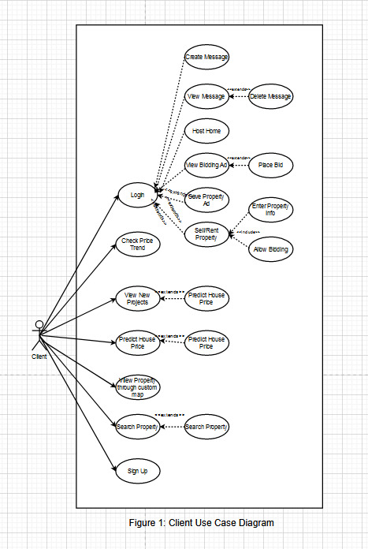

### Admin

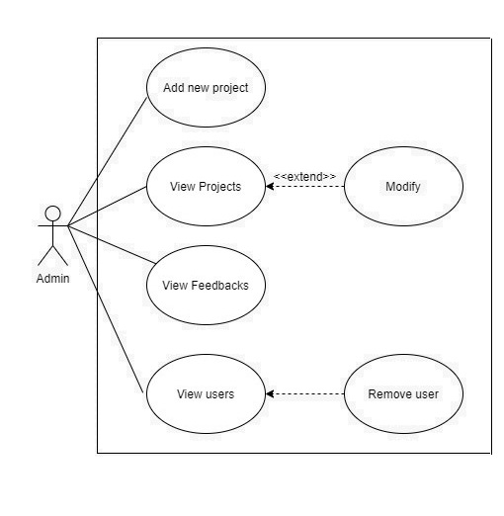

## Detailed Use Case

1. Sign Up

|  |  |  |
| --- | --- | --- |
| **Use Case ID:** | UC-1.1 | |
| **Use Case Name:** | Sign Up | |
| **Actors:** | Client | |
| **Description:** | User will be required to enter their first name, last name, location, email, password, phone number and it will be registered after validation | |
| **Trigger:** | User will press the Sign Up Button on the Home Page | |
| **Preconditions:** | N/A | |
| **Post conditions:** | * A Success Message will be shown which means the user is successfully registered and the user will be navigated to the homepage. * An Error Message will be shown which means there is something wrong in the fields. | |
| **Normal Flow:** | * User will enter the first name * User will enter the last name * User will enter the location * User will enter email and phone number * User will enter his password. * User will press the submit button * A Successful Message will be shown.. | |
| **Alternative**  **Flows[Alternative Flow 1 – Not in Network]:** | * User will enter the first name * User will enter the last name * User will enter email and phone number * User will enter his password. * User will press the submit button * An Error Message will be shown. | |
| **Exceptions:** | User enters incorrect first name, last name, email or phone number |
| **Business Rules:** | N/A |
| **Assumptions:** | * User should understand English in order to fill out the signup form |

1. Login

|  |  |  |
| --- | --- | --- |
| **Use Case ID:** | UC-1.2 | |
| **Use Case Name:** | Login | |
| **Actors:** | Admin, Client | |
| **Description:** | User will be allowed to log into the system | |
| **Trigger:** | User will press the login button | |
| **Preconditions:** | N/A | |
| **Post conditions:** | User will be logged into the system | |
| **Normal Flow:** | * User will enter username. * User will enter password. * User will click login button. * User will be logged in. | |
| **Alternative**  **Flows:** | N/A | |
| **Exceptions:** | User enters wrong username or password |
| **Business Rules:** | N/A |
| **Assumptions:** | * User has already been signed up |

1. Logout

|  |  |  |
| --- | --- | --- |
| **Use Case ID:** | UC-1.4 | |
| **Use Case Name:** | Logout | |
| **Actors:** | Admin, Client | |
| **Description:** | User will be allowed to log out of the system | |
| **Trigger:** | User will press the logout button | |
| **Preconditions:** | * User has logged in | |
| **Post conditions:** | User will be logged out of the system | |
| **Normal Flow:** | * User will open account dropdown menu * User will press log out * User will be logged out | |
| **Alternative**  **Flows:** | N/A | |
| **Exceptions:** | N/A |
| **Business Rules:** | N/A |
| **Assumptions:** | N/A |

1. Deactivate Account

|  |  |  |
| --- | --- | --- |
| **Use Case ID:** | UC-1.5 | |
| **Use Case Name:** | Deactivate Account | |
| **Actors:** | Client, House Builder | |
| **Description:** | User will be able to delete the account in the profile settings. | |
| **Trigger:** | User will press the deactivate my account button in profile settings. | |
| **Preconditions:** | * User has logged in | |
| **Post conditions:** | User account will be deactivated | |
| **Normal Flow:** | * User will go to my profile. * User will press the profile settings in my profile. * User will press the deactivate button. | |
| **Alternative**  **Flows:** | N/A | |
| **Exceptions:** | N/A |
| **Business Rules:** | N/A |
| **Assumptions:** | N/A |

1. Account Settings

|  |  |  |
| --- | --- | --- |
| **Use Case ID:** | UC-1.6 | |
| **Use Case Name:** | Account Settings | |
| **Actors:** | Client | |
| **Description:** | User will be given options to change their account name, password etc. | |
| **Trigger:** | User will press the account settings in my profile | |
| **Preconditions:** | * User has logged in | |
| **Post conditions:** | User will successfully change his account credentials | |
| **Normal Flow:** | * User will go to my profile. * User will press the profile settings in my profile. * User will update the options * User will press save changes button | |
| **Alternative**  **Flows:** | N/A | |
| **Exceptions:** | N/A |
| **Business Rules:** | N/A |
| **Assumptions:** | N/A |

1. View All Users

|  |  |  |
| --- | --- | --- |
| **Use Case ID:** | UC-1.7 | |
| **Use Case Name:** | View All Users | |
| **Actors:** | Admin | |
| **Description:** | Admin will be able to view all the users registered on the system | |
| **Trigger:** | Admin will press registered users button in the users section | |
| **Preconditions:** | * Admin has logged in | |
| **Post conditions:** | Admin will view a list of all registered users | |
| **Normal Flow:** | * Admin will click on users section * Admin will click on registered users button * Admin will view a list of all users | |
| **Alternative**  **Flows:** | N/A | |
| **Exceptions:** | N/A |
| **Business Rules:** | N/A |
| **Assumptions:** | N/A |

1. Remove User

|  |  |  |
| --- | --- | --- |
| **Use Case ID:** | UC-1.8 | |
| **Use Case Name:** | Remove User | |
| **Actors:** | Admin | |
| **Description:** | Admin will be able to remove a registered user from the system | |
| **Trigger:** | Admin will press on remove button associated with each user | |
| **Preconditions:** | * Admin has logged in | |
| **Post conditions:** | Admin will succesfully remove a user | |
| **Normal Flow:** | * Admin will click on users section * Admin will click on registered users button * Admin will view a list of all users * Admin will click on remove button * Admin will click on confirm button * Admin will see successfully deleted user message on screen | |
| **Alternative**  **Flows:** | N/A | |
| **Exceptions:** | N/A |
| **Business Rules:** | N/A |
| **Assumptions:** | N/A |

1. Search Property

|  |  |
| --- | --- |
| **Use Case ID:** | UC:2.1 |
| **Use Case Name:** | Search property |
| **Actors:** | Client |
| **Description:** | Client will be able to search for the type of property he is looking for |
| **Trigger:** | Client will click the buy property menu |
| **Preconditions:** | N/A |
| **Post conditions:** | Client will be able to select search options for property ads. |
| **Normal Flow:** | * Client will type his location * Client will select a location from the dropdown list * Client will select Buy or Rent option * Client may enter type of property * Client may enter price range * Client will click the search button |
| **Alternative Flows:** | N/A |
| **Exceptions:** |  |
| **Business Rules** | N/A |
| **Assumptions:** | N/A |
| **Includes** | N/A |

1. View property ads list

|  |  |
| --- | --- |
| **Use Case ID:** | UC:2.2 |
| **Use Case Name:** | View property ads list |
| **Actors:** | Client |
| **Description:** | Client will be able view the list of ads for the properties |
| **Trigger:** | Client will click the search button |
| **Preconditions:** | N/A |
| **Post conditions:** | Client will successfully view listed properties |
| **Normal Flow:** | * Client will click the search button * Client will scroll through the list and view ads |
| **Alternative Flows:** | N/A |
| **Exceptions:** | * No property found |
| **Business Rules** | N/A |
| **Assumptions:** | N/A |
| **Includes** | 2.2 |

1. Apply filters

|  |  |
| --- | --- |
| **Use Case ID:** | UC:2.3 |
| **Use Case Name:** | Apply filters |
| **Actors:** | Client |
| **Description:** | Client will be able to apply filters to change the search results |
| **Trigger:** | Apply Button |
| **Preconditions:** | N/A |
| **Post conditions:** | Client will be displayed the filtered ads list |
| **Normal Flow:** | * Client may select another location * Client may select a property type * Client may select a price range * Client will click the apply button |
| **Alternative Flows:** | N/A |
| **Exceptions:** |  |
| **Business Rules** | N/A |
| **Assumptions:** | N/A |
| **Includes** | 2.2 |

1. View property ad details

|  |  |
| --- | --- |
| **Use Case ID:** | UC:2.4 |
| **Use Case Name:** | View property ad details |
| **Actors:** | Client |
| **Description:** | Client will be able to view an ad from the list in detail |
| **Trigger:** | Client will click the view ad button |
| **Preconditions:** | N/A |
| **Post conditions:** | Client will be displayed the details of a property ad |
| **Normal Flow:** | * Client will click the ‘view details’ button * Client will be navigated and shown the ad details |
| **Alternative Flows:** | N/A |
| **Exceptions:** | N/A |
| **Business Rules** | N/A |
| **Assumptions:** | N/A |
| **Includes** | 2.2 |

1. House Sell/Rent Ad

|  |  |
| --- | --- |
| **Use Case ID:** | UC:3.1 |
| **Use Case Name:** | Post House Sell/Rent Ad |
| **Actors:** | Client |
| **Description:** | Client will be able to post an ad of their house to sell/rent |
| **Trigger:** | Client selects house sell/rent in post property ad section. |
| **Preconditions:** | * Client has logged in. |
| **Post conditions:** | Client will successfully post an ad of their house for sell/rent. |
| **Normal Flow:** | * Client will click on post property ad section. * Client will select house sell/rent from the list. * Client will fill out all the details of his house. * Client will click on post an ad button. |
| **Alternative Flows:** | N/A |
| **Exceptions:** | N/A |
| **Business Rules** | N/A |
| **Assumptions:** | N/A |

1. Plot Sell Ad

|  |  |
| --- | --- |
| **Use Case ID:** | UC:3.2 |
| **Use Case Name:** | Plot Sell Ad |
| **Actors:** | Client |
| **Description:** | Client will be able to post an ad of their plot to sell. |
| **Trigger:** | Client selects plot sell in post property ad section. |
| **Preconditions:** | * Client has logged in. |
| **Post conditions:** | Client will successfully post an ad of their plot for sell. |
| **Normal Flow:** | * Client will click on post property ad section. * Client will select plot sell from the list. * Client will fill out all the details of his plot. * Client will click on post an ad button. |
| **Alternative Flows:** | N/A |
| **Exceptions:** | N/A |
| **Business Rules** | N/A |
| **Assumptions:** | N/A |

1. Flat Sell/Rent Ad

|  |  |
| --- | --- |
| **Use Case ID:** | UC:3.3 |
| **Use Case Name:** | Flat Sell/Rent Ad |
| **Actors:** | Client |
| **Description:** | Client will be able to post an ad of their flat to sell/rent |
| **Trigger:** | Client selects flat sell/rent in post property ad section. |
| **Preconditions:** | * Client has logged in. |
| **Post conditions:** | Client will successfully post an ad of their flat for sell/rent. |
| **Normal Flow:** | * Client will click on post property ad section. * Client will select flat sell/rent from the list. * Client will fill out all the details of his house. * Client will clicks on post an ad button. |
| **Alternative Flows:** | N/A |
| **Exceptions:** | N/A |
| **Business Rules** | N/A |
| **Assumptions:** | N/A |

1. Commercial Business Sell/Rent Ad

|  |  |
| --- | --- |
| **Use Case ID:** | UC:3.4 |
| **Use Case Name:** | Commercial Business Sell/Rent Ad |
| **Actors:** | Client |
| **Description:** | Client will be able to post an ad of their commercial business to sell/rent |
| **Trigger:** | Client selects commercial business sell/rent in post property ad section. |
| **Preconditions:** | * Client has logged in. |
| **Post conditions:** | Client will successfully post an ad of their commercial business for sell/rent. |
| **Normal Flow:** | * Client will click on post property ad section. * Client will select commercial business sell/rent from the list. * Client will fill out all the details of his house. * Client will click on post an ad button. |
| **Alternative Flows:** | N/A |
| **Exceptions:** | N/A |
| **Business Rules** | N/A |
| **Assumptions:** | N/A |

1. View My Property Ads

|  |  |
| --- | --- |
| **Use Case ID:** | UC:3.6 |
| **Use Case Name:** | View My Property Ads |
| **Actors:** | Client |
| **Description:** | Client will be able to see all of the ads posted by him. |
| **Trigger:** | Client Presses “My property ads” button on his dashboard. |
| **Preconditions:** | * Client has logged in. |
| **Post conditions:** | Client will see a list of property ads posted by himself. |
| **Normal Flow:** | * Client will click on My property ads button. * Client will see a list of Property ads posted by himself. |
| **Alternative Flows:** | N/A |
| **Exceptions:** | N/A |
| **Business Rules** | N/A |
| **Assumptions:** | N/A |

1. Edit Property Ad

|  |  |
| --- | --- |
| **Use Case ID:** | UC:3.7 |
| **Use Case Name:** | Edit Property Ad |
| **Actors:** | Client |
| **Description:** | Client will be able to edit their already posted property ads. |
| **Trigger:** | Client presses edit property ads button. |
| **Preconditions:** | * Client has logged in. * Client has posted at least one Property ad. |
| **Post conditions:** | Client will be able to successfully edit their property ad. |
| **Normal Flow:** | * Client will click on my property ads button. * Client will click on an edit button associated with each ad. * Client will edit the ad and clicks on save button. * Client will see the successfully updated message on screen. |
| **Alternative Flows:** | N/A |
| **Exceptions:** | N/A |
| **Business Rules** | N/A |

1. Delete Property Ad

|  |  |
| --- | --- |
| **Use Case ID:** | UC:3.8 |
| **Use Case Name:** | Delete Property Ad |
| **Actors:** | Client |
| **Description:** | Client will be able to delete their property ad. |
| **Trigger:** | Client presses delete button associated with each property ad. |
| **Preconditions:** | * Client has logged in. * Client has posted at least one Property ad. |
| **Post conditions:** | Client will be able to successfully delete his property ad. |
| **Normal Flow:** | * Client will click on my property ads button * Client will click on a delete button associated with each ad * Client will see the successfully deleted message on screen |
| **Alternative Flows:** | N/A |
| **Exceptions:** | N/A |
| **Business Rules** | N/A |

1. Location

|  |  |
| --- | --- |
| **Use Case ID:** | UC:4.1 |
| **Use Case Name:** | Location |
| **Actors:** | Client |
| **Description:** | Client will be able give location of interest |
| **Trigger:** | Client clicks on the text field labelled as location |
| **Preconditions:** | Client must click on the price trends button on the home page. |
| **Post conditions:** | Client will have entered a desired location |
| **Normal Flow:** | * Client will click on Price Trends button * Client will enter location in the given text field |
| **Alternative Flows:** | N/A |
| **Exceptions:** |  |
| **Business Rules** | N/A |
| **Assumptions:** | N/A |

1. Trends

|  |  |
| --- | --- |
| **Use Case ID:** | UC:4.2 |
| **Use Case Name:** | Trends |
| **Actors:** | Client |
| **Description:** | Client will be able to find out about the price trends of the given location |
| **Trigger:** | Client clicks on the enter button located on the immediate right of the text field |
| **Preconditions:** | Client must click on the Price Trends button on the home page. |
| **Post conditions:** | Client will find out about the price trends in the entered location. |
| **Normal Flow:** | * Client will click on Price Trends button * Client will enter location in the given text field * Client will find out about the price trends of the given area. |
| **Alternative Flows:** | N/A |
| **Exceptions:** |  |
| **Business Rules** | N/A |
| **Assumptions:** | N/A |

1. Hot Projects

|  |  |
| --- | --- |
| **Use Case ID:** | UC:5.1 |
| **Use Case Name:** | Hot Projects |
| **Actors:** | Client |
| **Description:** | Client will be able to view Hot Trending New Projects Nationwide |
| **Trigger:** | Client clicks on the New Projects Button |
| **Preconditions:** | N/A |
| **Post conditions:** | Client will be able to view a list of trending projects Nationwide. |
| **Normal Flow:** | * Client will click on New Projects button * Client will see a list of new trending Projects. |
| **Alternative Flows:** | N/A |
| **Exceptions:** |  |
| **Business Rules** | N/A |
| **Assumptions:** | N/A |

1. Features

|  |  |
| --- | --- |
| **Use Case ID:** | UC:5.2 |
| **Use Case Name:** | Features |
| **Actors:** | Client |
| **Description:** | Client will be able to view the Features of the selected Project |
| **Trigger:** | Client clicks one of the Projects in the List |
| **Preconditions:** | N/A |
| **Post conditions:** | Client will view the Project Features |
| **Normal Flow:** | * Client will click on choice of Project. * Client will click on the Features button. * Client will successfully se the Project Features |
| **Alternative Flows:** | N/A |
| **Exceptions:** |  |
| **Business Rules** | N/A |
| **Assumptions:** | N/A |

1. Overview

|  |  |
| --- | --- |
| **Use Case ID:** | UC:5.3 |
| **Use Case Name:** | Overview |
| **Actors:** | Client |
| **Description:** | Client will be able to view the Overview of the selected Project |
| **Trigger:** | Client clicks one of the Projects in the List |
| **Preconditions:** | * N/A |
| **Post conditions:** | Client will view the Project Overview |
| **Normal Flow:** | * Client will click on choice of Project. * Client will click on the Overview button. * Client will successfully see the Overview |
| **Alternative Flows:** | N/A |
| **Exceptions:** |  |
| **Business Rules** | N/A |
| **Assumptions:** | N/A |

1. New Project proprietor/developer

|  |  |
| --- | --- |
| **Use Case ID:** | UC:5.4 |
| **Use Case Name:** | New Project proprietor/developer |
| **Actors:** | Client |
| **Description:** | Client will be able to view the Developers information of the selected Project |
| **Trigger:** | Client clicks one of the Projects in the List |
| **Preconditions:** | * N/A |
| **Post conditions:** | Client will view the Developers information |
| **Normal Flow:** | * Client will click on choice of Project. * Client will click on the Developers button. * Client will successfully see the Developers information. |
| **Alternative Flows:** | N/A |
| **Exceptions:** |  |
| **Business Rules** | N/A |
| **Assumptions:** | N/A |

1. Share New Project

|  |  |
| --- | --- |
| **Use Case ID:** | UC:5.5 |
| **Use Case Name:** | Share New Project |
| **Actors:** | Client |
| **Description:** | Client will be able to share the selected New Project |
| **Trigger:** | Client clicks the share button |
| **Preconditions:** | * N/A |
| **Post conditions:** | Client will be able to interact with the Projects |
| **Normal Flow:** | * Client will click on choice of Project. * Client will click on the Share button. |
| **Alternative Flows:** | N/A |
| **Exceptions:** |  |
| **Business Rules** | N/A |
| **Assumptions:** | N/A |

1. Like New Project

|  |  |
| --- | --- |
| **Use Case ID:** | UC:5.6 |
| **Use Case Name:** | Like New Project |
| **Actors:** | Client |
| **Description:** | Client will be able to like the selected New Project and view it later. |
| **Trigger:** | Client clicks the like button |
| **Preconditions:** | * N/A |
| **Post conditions:** | Client will like the Project he is viewing |
| **Normal Flow:** | * Client will click on choice of Project. * Client will click on the like button. |
| **Alternative Flows:** | N/A |
| **Exceptions:** |  |
| **Business Rules** | N/A |
| **Assumptions:** | N/A |

1. Add New Project

|  |  |
| --- | --- |
| **Use Case ID:** | UC:5.7 |
| **Use Case Name:** | Add New Project |
| **Actors:** | Admin |
| **Description:** | Admin will be able to add a New Project |
| **Trigger:** | Admin clicks the add New Project button |
| **Preconditions:** | * Logged in as Admin |
| **Post conditions:** | Admin will have added the New Project |
| **Normal Flow:** | * Admin will log in * Admin will go to the New Projects menu * Admin will click the ‘Add’ button * Admin will put information of ‘New Project’ in alotted space * Admin will add New Project |
| **Alternative Flows:** | N/A |
| **Exceptions:** |  |
| **Business Rules** | N/A |
| **Assumptions:** | N/A |

1. View Custom Maps

|  |  |
| --- | --- |
| **Use Case ID:** | UC:6.1 |
| **Use Case Name:** | View Custom Maps |
| **Actors:** | Client |
| **Description:** | Client will be able to view listed properties on the maps |
| **Trigger:** | Client presses custom map button |
| **Preconditions:** | N/A |
| **Post conditions:** | Client will be able to view properties on map |
| **Normal Flow:** | * Client will click on custom maps section * Client will view the properties on map |
| **Alternative Flows:** | N/A |
| **Exceptions:** | N/A |
| **Business Rules** | N/A |

1. View Property Details

|  |  |
| --- | --- |
| **Use Case ID:** | UC:6.2 |
| **Use Case Name:** | View Property Details |
| **Actors:** | Client |
| **Description:** | Client will be able to view details of a listed properties on the map |
| **Trigger:** | Client presses clicks on a p |
| **Preconditions:** | * UC:6.1 |
| **Post conditions:** | Client will be able to view property details on map |
| **Normal Flow:** | * Client will click on custom maps section * Client will click the properties on maps * Client will click a property from the map * Client will see the property details |
| **Alternative Flows:** | N/A |
| **Exceptions:** | N/A |
| **Business Rules** | N/A |

1. House Details

|  |  |
| --- | --- |
| **Use Case ID:** | UC:7.1 |
| **Use Case Name:** | House Details |
| **Actors:** | Client |
| **Description:** | Client will be able to enter their house details to predict its price. |
| **Trigger:** | Client presses add house details button in property price prediction section. |
| **Preconditions:** | N/A |
| **Post conditions:** | Client will be able to successfully enter their house details. |
| **Normal Flow:** | * Client will click on property price prediction section. * Client will click on add house details. * Client will click the submit button. |
| **Alternative Flows:** | N/A |
| **Exceptions:** | N/A |
| **Business Rules** | N/A |

1. Flat Details

|  |  |
| --- | --- |
| **Use Case ID:** | UC:7.2 |
| **Use Case Name:** | Flat Details |
| **Actors:** | Client |
| **Description:** | Client will be able to enter their flat details to predict its price. |
| **Trigger:** | Client presses add flat details button in property price prediction section. |
| **Preconditions:** | N/A |
| **Post conditions:** | Client will be able to successfully enter details. |
| **Normal Flow:** | * Client will click on property price prediction section. * Client will click on add flat details. * Client will click the submit button. |
| **Alternative Flows:** | N/A |
| **Exceptions:** | N/A |
| **Business Rules** | N/A |

1. View Price Prediction Details

|  |  |
| --- | --- |
| **Use Case ID:** | UC:7.3 |
| **Use Case Name:** | View Price Prediction Details |
| **Actors:** | Client |
| **Description:** | Client will be able to view details of their property predicted price. |
| **Trigger:** | Client presses view prediction details button. |
| **Preconditions:** | * UC:7.1 * UC:7.2 |
| **Post conditions:** | Client will be able to successfully view the predicted price details. |
| **Normal Flow:** | * Client will click on view prediction details. * Client will see details of his property predicted price. |
| **Alternative Flows:** | N/A |
| **Exceptions:** | N/A |
| **Business Rules** | N/A |

1. Find House

|  |  |
| --- | --- |
| **Use Case ID:** | UC:9.1 |
| **Use Case Name:** | Find House |
| **Actors:** | Client |
| **Description:** | Client will be able to find a house |
| **Trigger:** | Client clicks on the find house button |
| **Preconditions:** | N/A |
| **Post conditions:** | Client will be able to find nearby houses |
| **Normal Flow:** | * Client will click on Hosting button on the main menu * Client will click on the Find House Button |
| **Alternative Flows:** | N/A |
| **Exceptions:** | N/A |
| **Business Rules** | N/A |
| **Assumptions:** | N/A |

1. Choose Sharable house

|  |  |
| --- | --- |
| **Use Case ID:** | UC:9.2 |
| **Use Case Name:** | Choose Sharable house |
| **Actors:** | Client |
| **Description:** | Client will be able to choose sharable house |
| **Trigger:** | After location , check in , check out , no. of people are added |
| **Preconditions:** | N/A |
| **Post conditions:** | Client will get sharable houses according to entered info |
| **Normal Flow:** | * Client will enter required info * Client will get list of sharable houses |
| **Alternative Flows:** | N/A |
| **Exceptions:** | N/A |
| **Business Rules** | N/A |
| **Assumptions:** | N/A |

1. Rate Sharable House

|  |  |
| --- | --- |
| **Use Case ID:** | UC:9.3 |
| **Use Case Name:** | Rate Sharable house |
| **Actors:** | Client |
| **Description:** | Client will be able to rate sharable house |
| **Trigger:** | Rating button |
| **Preconditions:** | N/A |
| **Post conditions:** | Client will have rated property |
| **Normal Flow:** | * Client will view a single Sharable house * Client will rate it |
| **Alternative Flows:** | N/A |
| **Exceptions:** | N/A |
| **Business Rules** | N/A |
| **Assumptions:** | N/A |

1. Share House

|  |  |
| --- | --- |
| **Use Case ID:** | UC:9.4 |
| **Use Case Name:** | Share House |
| **Actors:** | Client |
| **Description:** | Client will be able to put their own house for sharing |
| **Trigger:** | Share your house button |
| **Preconditions:** | N/A |
| **Post conditions:** | Client will have shared their own house |
| **Normal Flow:** | * Client will click Share your house button on the main menu |
| **Alternative Flows:** | N/A |
| **Exceptions:** | N/A |
| **Business Rules** | N/A |
| **Assumptions:** | N/A |

1. My shared properties

|  |  |
| --- | --- |
| **Use Case ID:** | UC:9.5 |
| **Use Case Name:** | My shared properties |
| **Actors:** | Client |
| **Description:** | Client will be able to get their shared properties |
| **Trigger:** | Client clicks the my shared properties button |
| **Preconditions:** | N/A |
| **Post conditions:** | Client will be able to get their shared properties |
| **Normal Flow:** | * Client will click on the ‘Hosting’ button on the main page * Client will click on the ‘My shared properties’ button |
| **Alternative Flows:** | N/A |
| **Exceptions:** | N/A |
| **Business Rules** | N/A |
| **Assumptions:** | N/A |

1. Property Book requests

|  |  |
| --- | --- |
| **Use Case ID:** | UC:9.6 |
| **Use Case Name:** | Property Book Request |
| **Actors:** | Client |
| **Description:** | Client will be able to get a request if another client wants to book his property |
| **Trigger:** | Client clicks ‘requests’ button |
| **Preconditions:** | N/A |
| **Post conditions:** | Client will be able to receive booking requests |
| **Normal Flow:** | * Client will click on Hosting button on main page * Client will click on ’requests ‘ button |
| **Alternative Flows:** | N/A |
| **Exceptions:** | N/A |
| **Business Rules** | N/A |
| **Assumptions:** | N/A |

1. View Chat List

|  |  |
| --- | --- |
| **Use Case ID:** | UC:10.1 |
| **Use Case Name:** | View Chat List |
| **Actors:** | Client |
| **Description:** | Client will be able to see a list of all their chats. |
| **Trigger:** | Client clicks ‘chat’ button |
| **Preconditions:** | N/A |
| **Post conditions:** | Client will be able to view chat list |
| **Normal Flow:** | * Client will click on Chat button on main page * Client will see a list of all their chats |
| **Alternative Flows:** | N/A |
| **Exceptions:** | N/A |
| **Business Rules** | N/A |
| **Assumptions:** | N/A |

1. View Messages

|  |  |
| --- | --- |
| **Use Case ID:** | UC:10.2 |
| **Use Case Name:** | View Messages |
| **Actors:** | Client |
| **Description:** | Client will be able to see all messages from a particular chat |
| **Trigger:** | Client clicks on a particular chat in ‘chat’ section |
| **Preconditions:** | N/A |
| **Post conditions:** | Client will be able to view messages |
| **Normal Flow:** | * Client will click on Chat button on main page * Client will see a list of all their chats * Client will click on one of their chat * Client will see messages from that particular chat |
| **Alternative Flows:** | N/A |
| **Exceptions:** | N/A |
| **Business Rules** | N/A |
| **Assumptions:** | N/A |

1. Send Message

|  |  |
| --- | --- |
| **Use Case ID:** | UC:10.3 |
| **Use Case Name:** | Send Message |
| **Actors:** | Client |
| **Description:** | Client will be able to send a message in a particular chat |
| **Trigger:** | Client clicks send message in a particular chat |
| **Preconditions:** | N/A |
| **Post conditions:** | Client will be able to send message |
| **Normal Flow:** | * Client will click on Chat button on main page * Client will see a list of all their chats * Client will click on one of their chat * Client will type message and click send message button |
| **Alternative Flows:** | N/A |
| **Exceptions:** | N/A |
| **Business Rules** | N/A |
| **Assumptions:** | N/A |

## Functional Requirements

|  |  |
| --- | --- |
| **Identifier** | FR-1.1 |
| **Title** | Enter First Name |
| **Requirement** | Client shall be able to their first name |
| **Source** | Group Member 2 |
| **Rationale** | In order to set first name of new client |
| **Business Rule (if required)** | Nil |
| **Dependencies** | FR-1.7 |
| **Priority** | High |

|  |  |
| --- | --- |
| **Identifier** | FR-1.2 |
| **Title** | Enter Last Name |
| **Requirement** | Client shall be able to enter their last name |
| **Source** | Group Member 2 |
| **Rationale** | In order to set last name of new client |
| **Business Rule (if required)** | Nil |
| **Dependencies** | FR-1.7 |
| **Priority** | High |

|  |  |
| --- | --- |
| **Identifier** | FR-1.3 |
| **Title** | Enter Location |
| **Requirement** | Client shall be able to enter their location |
| **Source** | Group Member 2 |
| **Rationale** | In order to set location of new client |
| **Business Rule (if required)** | Nil |
| **Dependencies** | FR-1.7 |
| **Priority** | High |

|  |  |
| --- | --- |
| **Identifier** | FR-1.4 |
| **Title** | Enter Email |
| **Requirement** | Client shall be able to enter their valid email |
| **Source** | Group Member 2 |
| **Rationale** | In order to set email of new client |
| **Business Rule (if required)** | Nil |
| **Dependencies** | FR-1.7 |
| **Priority** | High |

|  |  |
| --- | --- |
| **Identifier** | FR-1.5 |
| **Title** | Enter Phone no |
| **Requirement** | Client shall be able to enter their valid phone no |
| **Source** | Group Member 2 |
| **Rationale** | In order to set phone no of new client |
| **Business Rule (if required)** | Nil |
| **Dependencies** | FR-1.7 |
| **Priority** | High |

|  |  |
| --- | --- |
| **Identifier** | FR-1.6 |
| **Title** | Enter Password |
| **Requirement** | Client shall be able to enter their password minimum 8 characters |
| **Source** | Group Member 2 |
| **Rationale** | In order to set password of new client |
| **Business Rule (if required)** | Nil |
| **Dependencies** | FR-1.7 |
| **Priority** | High |

|  |  |
| --- | --- |
| **Identifier** | FR-1.7 |
| **Title** | Sign Up |
| **Requirement** | Client shall be able to sign up |
| **Source** | Group Member 2 |
| **Rationale** | In order to register new client |
| **Business Rule (if required)** | Nil |
| **Dependencies** | FR-1.8 |
| **Priority** | High |

|  |  |
| --- | --- |
| **Identifier** | FR-1.8 |
| **Title** | Successful Message |
| **Requirement** | Client shall be able to view successful message of his registration |
| **Source** | Group Member 2 |
| **Rationale** | In order to successfully register a client |
| **Business Rule (if required)** | Nil |
| **Dependencies** | Nil |
| **Priority** | High |

|  |  |
| --- | --- |
| **Identifier** | FR-1.9 |
| **Title** | Error Message |
| **Requirement** | Client shall be able to view error message upon his registration |
| **Source** | Group Member 2 |
| **Rationale** | In order to show incorrect fields during registration |
| **Business Rule (if required)** | Nil |
| **Dependencies** | Nil |
| **Priority** | High |

|  |  |
| --- | --- |
| **Identifier** | FR-1.10 |
| **Title** | Enter Email |
| **Requirement** | User shall be able to enter their email |
| **Source** | Group Member 2 |
| **Rationale** | In order to login to the system |
| **Business Rule (if required)** | Nil |
| **Dependencies** | Nil |
| **Priority** | High |

|  |  |
| --- | --- |
| **Identifier** | FR-1.11 |
| **Title** | Enter Password |
| **Requirement** | User shall be able to enter their valid password |
| **Source** | Group Member 2 |
| **Rationale** | In order to login to the system |
| **Business Rule (if required)** | Nil |
| **Dependencies** | Nil |
| **Priority** | High |

|  |  |
| --- | --- |
| **Identifier** | FR-1.12 |
| **Title** | Login |
| **Requirement** | On clicking login, user shall be able to login to the system |
| **Source** | Group Member 2 |
| **Rationale** | In order to login to the system |
| **Business Rule (if required)** | Nil |
| **Dependencies** | FR-1.16 |
| **Priority** | High |

|  |  |
| --- | --- |
| **Identifier** | FR-1.13 |
| **Title** | Logout |
| **Requirement** | On clicking logout, User shall be able to logout from the system |
| **Source** | Group Member 2 |
| **Rationale** | In order to logout the user from system |
| **Business Rule (if required)** | Nil |
| **Dependencies** | Nil |
| **Priority** | High |

|  |  |
| --- | --- |
| **Identifier** | FR-1.14 |
| **Title** | Profile Settings |
| **Requirement** | On clicking my profile, Client shall be enter his profile |
| **Source** | Group Member 2 |
| **Rationale** | In order to allow client to access their profile |
| **Business Rule (if required)** | Nil |
| **Dependencies** | Nil |
| **Priority** | High |

|  |  |
| --- | --- |
| **Identifier** | FR-1.15 |
| **Title** | Edit First Name |
| **Requirement** | Client shall be able to edit their first name |
| **Source** | Group Member 2 |
| **Rationale** | In order to update client first name |
| **Business Rule (if required)** | Nil |
| **Dependencies** | Nil |
| **Priority** | High |

|  |  |
| --- | --- |
| **Identifier** | FR-1.16 |
| **Title** | Edit Last Name |
| **Requirement** | Client shall be able to edit their last name |
| **Source** | Group Member 2 |
| **Rationale** | In order to update client last name |
| **Business Rule (if required)** | Nil |
| **Dependencies** | Nil |
| **Priority** | High |

|  |  |
| --- | --- |
| **Identifier** | FR-1.17 |
| **Title** | Enter Current Password |
| **Requirement** | User shall be able to enter their current password |
| **Source** | Group Member 2 |
| **Rationale** | In order to change user password |
| **Business Rule (if required)** | Nil |
| **Dependencies** | Nil |
| **Priority** | High |

|  |  |
| --- | --- |
| **Identifier** | FR-1.18 |
| **Title** | Enter new Password |
| **Requirement** | User shall be able to enter their new password |
| **Source** | Group Member 2 |
| **Rationale** | In order to change user password |
| **Business Rule (if required)** | Nil |
| **Dependencies** | Nil |
| **Priority** | High |

|  |  |
| --- | --- |
| **Identifier** | FR-1.19 |
| **Title** | Save Changes |
| **Requirement** | On clicking save changes button, user shall be able to save their changes |
| **Source** | Group Member 2 |
| **Rationale** | In order to update user settings |
| **Business Rule (if required)** | Nil |
| **Dependencies** | Nil |
| **Priority** | High |

|  |  |
| --- | --- |
| **Identifier** | FR-1.20 |
| **Title** | Deactivate Account |
| **Requirement** | On clicking deactivate button, user shall be able to deactivate their account |
| **Source** | Group Member 2 |
| **Rationale** | In order to delete account info from the system |
| **Business Rule (if required)** | Nil |
| **Dependencies** | Nil |
| **Priority** | High |

|  |  |
| --- | --- |
| **Identifier** | FR-1.21 |
| **Title** | View All Users |
| **Requirement** | On clicking view users button, admin shall be able to view a list of all registered users |
| **Source** | Group Member 2 |
| **Rationale** | In order to view all registered users |
| **Business Rule (if required)** | Nil |
| **Dependencies** | FR-1.22 |
| **Priority** | High |

|  |  |
| --- | --- |
| **Identifier** | FR-1.22 |
| **Title** | Remove User |
| **Requirement** | On clicking remove user button, admin shall be able to remove a user from the system |
| **Source** | Group Member 2 |
| **Rationale** | In order to remove a user from the system |
| **Business Rule (if required)** | Nil |
| **Dependencies** | Nil |
| **Priority** | High |

|  |  |
| --- | --- |
| **Identifier** | FR-2.1 |
| **Title** | Buy property section |
| **Requirement** | On clicking buy property section, user shall be able to enter buy section |
| **Source** | Group Member 2 |
| **Rationale** | In order to enter buy property section |
| **Business Rule (if required)** | Nil |
| **Dependencies** | Nil |
| **Priority** | High |

|  |  |
| --- | --- |
| **Identifier** | FR-2.2 |
| **Title** | Select Location |
| **Requirement** | User shall be able to select location of property |
| **Source** | Group Member 2 |
| **Rationale** | In order to search property |
| **Business Rule (if required)** | Nil |
| **Dependencies** | Nil |
| **Priority** | High |

|  |  |
| --- | --- |
| **Identifier** | FR-2.3 |
| **Title** | Select Buy/Rent |
| **Requirement** | User shall be able to select buy/rent for property |
| **Source** | Group Member 2 |
| **Rationale** | In order to search property |
| **Business Rule (if required)** | Nil |
| **Dependencies** | Nil |
| **Priority** | High |

|  |  |
| --- | --- |
| **Identifier** | FR-2.4 |
| **Title** | Enter Type |
| **Requirement** | User shall be able to select type of property |
| **Source** | Group Member 2 |
| **Rationale** | In order to search property |
| **Business Rule (if required)** | Nil |
| **Dependencies** | Nil |
| **Priority** | High |

|  |  |
| --- | --- |
| **Identifier** | FR-2.5 |
| **Title** | Select Price Range |
| **Requirement** | User shall be able to select price range of property |
| **Source** | Group Member 2 |
| **Rationale** | In order to search property |
| **Business Rule (if required)** | Nil |
| **Dependencies** | Nil |
| **Priority** | High |

|  |  |
| --- | --- |
| **Identifier** | FR-2.6 |
| **Title** | Search |
| **Requirement** | By clicking search, user shall be able to search for properties |
| **Source** | Group Member 2 |
| **Rationale** | In order to search for property ads |
| **Business Rule (if required)** | Nil |
| **Dependencies** | Nil |
| **Priority** | High |

|  |  |
| --- | --- |
| **Identifier** | FR-2.7 |
| **Title** | View Property Ads List |
| **Requirement** | User shall be able view list of properties ads |
| **Source** | Group Member 2 |
| **Rationale** | In order to view properties list |
| **Business Rule (if required)** | Nil |
| **Dependencies** | Nil |
| **Priority** | High |

|  |  |
| --- | --- |
| **Identifier** | FR-2.8 |
| **Title** | View Property Ad |
| **Requirement** | On clicking a property, user shall be able to view details of a property ad |
| **Source** | Group Member 2 |
| **Rationale** | In order to view details of a property ad |
| **Business Rule (if required)** | Nil |
| **Dependencies** | Nil |
| **Priority** | High |

|  |  |
| --- | --- |
| **Identifier** | FR-3.1 |
| **Title** | Post Property Ad |
| **Requirement** | On clicking post property ad, Client shall enter post property ad section |
| **Source** | Group Member 1 |
| **Rationale** | In order to enter details of new property ad |
| **Business Rule (if required)** | Nil |
| **Dependencies** | Nil |
| **Priority** | High |

|  |  |
| --- | --- |
| **Identifier** | FR-3.2 |
| **Title** | Select Property Type |
| **Requirement** | Client shall select the property type |
| **Source** | Group Member 1 |
| **Rationale** | In order to assign property type to the new property ad |
| **Business Rule (if required)** | Nil |
| **Dependencies** | FR-3.11 |
| **Priority** | High |

|  |  |
| --- | --- |
| **Identifier** | FR-3.3 |
| **Title** | Enter Property Description |
| **Requirement** | Client shall enter the property description |
| **Source** | Group Member 1 |
| **Rationale** | In order to assign property description to the new property ad |
| **Business Rule (if required)** | Nil |
| **Dependencies** | FR-3.11 |
| **Priority** | High |

|  |  |
| --- | --- |
| **Identifier** | FR-3.4 |
| **Title** | Enter Property Pictures |
| **Requirement** | Client shall enter the property pictures |
| **Source** | Group Member 1 |
| **Rationale** | In order to assign property pictures to the new property ad |
| **Business Rule (if required)** | Nil |
| **Dependencies** | FR-3.11 |
| **Priority** | High |

|  |  |
| --- | --- |
| **Identifier** | FR-3.5 |
| **Title** | Enter Area |
| **Requirement** | Client shall enter the area for the property ad |
| **Source** | Group Member 1 |
| **Rationale** | In order to assign area for the property ad |
| **Business Rule (if required)** | Nil |
| **Dependencies** | FR-3.11 |
| **Priority** | High |

|  |  |
| --- | --- |
| **Identifier** | FR-3.6 |
| **Title** | Enter House Rooms |
| **Requirement** | Client shall enter the house rooms for the house ad. |
| **Source** | Group Member 1 |
| **Rationale** | In order to assign house rooms to the new house ad. |
| **Business Rule (if required)** | Nil |
| **Dependencies** | FR-3.11 |
| **Priority** | High |

|  |  |
| --- | --- |
| **Identifier** | FR-3.7 |
| **Title** | Enter House Baths |
| **Requirement** | Client shall enter the house baths for the house ad. |
| **Source** | Group Member 1 |
| **Rationale** | In order to assign house baths to the new house ad. |
| **Business Rule (if required)** | Nil |
| **Dependencies** | FR-3.11 |
| **Priority** | High |

|  |  |
| --- | --- |
| **Identifier** | FR-3.8 |
| **Title** | Enter House Floors |
| **Requirement** | Client shall enter the house floors for the house ad. |
| **Source** | Group Member 1 |
| **Rationale** | In order to assign house floors to the new house ad. |
| **Business Rule (if required)** | Nil |
| **Dependencies** | FR-3.11 |
| **Priority** | High |

|  |  |
| --- | --- |
| **Identifier** | FR-3.9 |
| **Title** | Choose Sell/Rent |
| **Requirement** | Client shall select the sell/rent option for the house/flat ad. |
| **Source** | Group Member 1 |
| **Rationale** | In order to assign sell/rent to the new house/flat ad. |
| **Business Rule (if required)** | Nil |
| **Dependencies** | FR-3.11 |
| **Priority** | High |

|  |  |
| --- | --- |
| **Identifier** | FR-3.10 |
| **Title** | Enter Price |
| **Requirement** | Client shall enter the enter price for the property ad |
| **Source** | Group Member 1 |
| **Rationale** | In order to assign price to the new property ad |
| **Business Rule (if required)** | Nil |
| **Dependencies** | FR-3.11 |
| **Priority** | High |

|  |  |
| --- | --- |
| **Identifier** | FR-3.11 |
| **Title** | Post Ad |
| **Requirement** | On clicking post ad button, new ad shall be posted |
| **Source** | Group Member 1 |
| **Rationale** | In order to post a new ad |
| **Business Rule (if required)** | Nil |
| **Dependencies** | Nil |
| **Priority** | High |

|  |  |
| --- | --- |
| **Identifier** | FR-3.12 |
| **Title** | View My ads |
| **Requirement** | On clicking my ads, a list of ads posted by client himself shall be shown |
| **Source** | Group Member 1 |
| **Rationale** | In order to view list of ads posted. |
| **Business Rule (if required)** | Nil |
| **Dependencies** | Nil |
| **Priority** | High |

|  |  |
| --- | --- |
| **Identifier** | FR-3.13 |
| **Title** | Update My ads |
| **Requirement** | On clicking edit, Client shall be able to edit details of his property ad |
| **Source** | Group Member 1 |
| **Rationale** | In order to edit the posted ads |
| **Business Rule (if required)** | Nil |
| **Dependencies** | Nil |
| **Priority** | High |

|  |  |
| --- | --- |
| **Identifier** | FR-3.14 |
| **Title** | Edit Area |
| **Requirement** | Client shall be able to edit the area |
| **Source** | Group Member 1 |
| **Rationale** | In order to update area of a property ad |
| **Business Rule (if required)** | Nil |
| **Dependencies** | Nil |
| **Priority** | High |

|  |  |
| --- | --- |
| **Identifier** | FR-3.15 |
| **Title** | Edit House Baths |
| **Requirement** | Client shall be able to edit the house baths |
| **Source** | Group Member 1 |
| **Rationale** | In order to update baths of a house ad |
| **Business Rule (if required)** | Nil |
| **Dependencies** | Nil |
| **Priority** | High |

|  |  |
| --- | --- |
| **Identifier** | FR-3.16 |
| **Title** | Edit House Rooms |
| **Requirement** | Client shall be able to edit the house rooms |
| **Source** | Group Member 1 |
| **Rationale** | In order to update rooms of a house ad |
| **Business Rule (if required)** | Nil |
| **Dependencies** | Nil |
| **Priority** | High |

|  |  |
| --- | --- |
| **Identifier** | FR-3.17 |
| **Title** | Edit House Floors |
| **Requirement** | Client shall be able to edit the house floors |
| **Source** | Group Member 1 |
| **Rationale** | In order to update floors of a house ad |
| **Business Rule (if required)** | Nil |
| **Dependencies** | Nil |
| **Priority** | High |

|  |  |
| --- | --- |
| **Identifier** | FR-3.18 |
| **Title** | Edit Price |
| **Requirement** | Client shall be able to edit the price |
| **Source** | Group Member 1 |
| **Rationale** | In order to update price of a property ad |
| **Business Rule (if required)** | Nil |
| **Dependencies** | Nil |
| **Priority** | High |

|  |  |
| --- | --- |
| **Identifier** | FR-3.19 |
| **Title** | Update Ad |
| **Requirement** | On clicking update ad, the ad shall be updated |
| **Source** | Group Member 1 |
| **Rationale** | In order to update the ad |
| **Business Rule (if required)** | Nil |
| **Dependencies** | Nil |
| **Priority** | High |

|  |  |
| --- | --- |
| **Identifier** | FR-3.20 |
| **Title** | Delete Ad |
| **Requirement** | On clicking delete ad, the ad shall be deleted |
| **Source** | Group Member 1 |
| **Rationale** | In order to delete the ad |
| **Business Rule (if required)** | Nil |
| **Dependencies** | Nil |
| **Priority** | High |

|  |  |
| --- | --- |
| **Identifier** | FR-4.1 |
| **Title** | Enter Location |
| **Requirement** | Client shall be able to Enter desired location |
| **Source** | Group Member 2 |
| **Rationale** | In order to find out price trends of a particular location |
| **Business Rule (if required)** | Nil |
| **Dependencies** | Nil |
| **Priority** | High |

|  |  |
| --- | --- |
| **Identifier** | FR-4.2 |
| **Title** | View Price trend |
| **Requirement** | Client will be able to view Price trends of the given area |
| **Source** | Group Member 2 |
| **Rationale** | In order to view Price trends |
| **Business Rule (if required)** | Nil |
| **Dependencies** | FR-4.1 |
| **Priority** | High |

|  |  |
| --- | --- |
| **Identifier** | FR-4.3 |
| **Title** | Share Price Trend |
| **Requirement** | Client will be able to share the trends |
| **Source** | Group Member 2 |
| **Rationale** | In order to share Price trends |
| **Business Rule (if required)** | Nil |
| **Dependencies** | FR-4.1 |
| **Priority** | High |

|  |  |
| --- | --- |
| **Identifier** | FR-5.1 |
| **Title** | View Hot Projects |
| **Requirement** | Client shall be able to view Hot Projects |
| **Source** | Group Member 3 |
| **Rationale** | In order to view all hot projects |
| **Business Rule (if required)** | Nil |
| **Dependencies** | - |
| **Priority** | High |

|  |  |
| --- | --- |
| **Identifier** | FR-5.2 |
| **Title** | Modify Hot Project |
| **Requirement** | Client shall be able to modify a single Hot Project |
| **Source** | Group Member 3 |
| **Rationale** | In order to modify a single Hot Project |
| **Business Rule (if required)** | Nil |
| **Dependencies** | FR-5.1 |
| **Priority** | High |

|  |  |
| --- | --- |
| **Identifier** | FR-5.3 |
| **Title** | Delete Hot Project |
| **Requirement** | Client shall be able to delete a single Hot Project |
| **Source** | Group Member 3 |
| **Rationale** | In order to delete a single Hot Project |
| **Business Rule (if required)** | Nil |
| **Dependencies** | FR-7.1 |
| **Priority** | High |

|  |  |
| --- | --- |
| **Identifier** | FR-5.4 |
| **Title** | View Hot Project Features |
| **Requirement** | Client shall be able to view Features of a single Hot Project |
| **Source** | Group Member 3 |
| **Rationale** | In order to view Features of a single Hot Project |
| **Business Rule (if required)** | Nil |
| **Dependencies** | FR-5.1 |
| **Priority** | High |

|  |  |
| --- | --- |
| **Identifier** | FR-5.5 |
| **Title** | View Hot Project Overview |
| **Requirement** | Client shall be able to view Overview of a single Hot Project |
| **Source** | Group Member 3 |
| **Rationale** | In order to view Overview of a single Hot Project |
| **Business Rule (if required)** | Nil |
| **Dependencies** | FR-5.1 |
| **Priority** | High |

|  |  |
| --- | --- |
| **Identifier** | FR-5.6 |
| **Title** | View Hot Project Developers |
| **Requirement** | Client shall be able to view Developers of a single Hot Project |
| **Source** | Group Member 3 |
| **Rationale** | In order to view Developers of a single Hot Project |
| **Business Rule (if required)** | Nil |
| **Dependencies** | FR-5.1 |
| **Priority** | High |

|  |  |
| --- | --- |
| **Identifier** | FR-5.7 |
| **Title** | Share Hot Project |
| **Requirement** | Client shall be able to share a single Hot Project |
| **Source** | Group Member 3 |
| **Rationale** | In order to share a single Hot Project |
| **Business Rule (if required)** | Nil |
| **Dependencies** | FR-5.1 |
| **Priority** | High |

|  |  |
| --- | --- |
| **Identifier** | FR-5.8 |
| **Title** | Like Hot Project |
| **Requirement** | Client shall be able to like a single Hot Project |
| **Source** | Group Member 3 |
| **Rationale** | In order to like a single Hot Project |
| **Business Rule (if required)** | Nil |
| **Dependencies** | FR-5.1 |
| **Priority** | High |

|  |  |
| --- | --- |
| **Identifier** | FR-5.9 |
| **Title** | Enter Project Name |
| **Requirement** | Admin shall be able to enter Hot Project Name |
| **Source** | Group Member 3 |
| **Rationale** | In order to Enter a name of a single Hot Project |
| **Business Rule (if required)** | Nil |
| **Dependencies** | FR-5.1 |
| **Priority** | High |

|  |  |
| --- | --- |
| **Identifier** | FR-5.10 |
| **Title** | Enter Project Features |
| **Requirement** | Admin shall be able to enter Hot Project Features |
| **Source** | Group Member 3 |
| **Rationale** | In order to Enter Features of a single Hot Project |
| **Business Rule (if required)** | Nil |
| **Dependencies** | FR-5.1 |
| **Priority** | High |

|  |  |
| --- | --- |
| **Identifier** | FR-5.11 |
| **Title** | Enter Project Overview |
| **Requirement** | Admin shall be able to enter Hot Project Overview |
| **Source** | Group Member 3 |
| **Rationale** | In order to Enter overview of a single Hot Project |
| **Business Rule (if required)** | Nil |
| **Dependencies** | FR-5.1 |
| **Priority** | High |

|  |  |
| --- | --- |
| **Identifier** | FR-5.12 |
| **Title** | Enter Project Developer |
| **Requirement** | Admin shall be able to enter Hot Project Developer |
| **Source** | Group Member 3 |
| **Rationale** | In order to Enter the name of the developer of a single Hot Project |
| **Business Rule (if required)** | Nil |
| **Dependencies** | FR-5.1 |
| **Priority** | High |

|  |  |
| --- | --- |
| **Identifier** | FR-6.1 |
| **Title** | View Custom Maps |
| **Requirement** | On clicking custom maps button, client shall be able to view properties on map |
| **Source** | Group Member 3 |
| **Rationale** | In order to view properties on a map |
| **Business Rule (if required)** | Nil |
| **Dependencies** | Nil |
| **Priority** | High |

|  |  |
| --- | --- |
| **Identifier** | FR-6.2 |
| **Title** | View Properties Details |
| **Requirement** | On clicking a property, client shall be able to view properties details on map |
| **Source** | Group Member 3 |
| **Rationale** | In order to view properties details on a map |
| **Business Rule (if required)** | Nil |
| **Dependencies** | FR-6.1 |
| **Priority** | High |

|  |  |
| --- | --- |
| **Identifier** | FR-7.1 |
| **Title** | Price Prediction Section |
| **Requirement** | On clicking price prediction button, client shall enters the price prediction details |
| **Source** | Group Member 1 |
| **Rationale** | In order to enter price prediction section. |
| **Business Rule (if required)** | Nil |
| **Dependencies** | Nil |
| **Priority** | High |

|  |  |
| --- | --- |
| **Identifier** | FR-7.2 |
| **Title** | Select House/Flat |
| **Requirement** | Client shall selects the house/flat option |
| **Source** | Group Member 1 |
| **Rationale** | In order to get property type for the price prediction |
| **Business Rule (if required)** | Nil |
| **Dependencies** | FR-7.8 |
| **Priority** | High |

|  |  |
| --- | --- |
| **Identifier** | FR-7.3 |
| **Title** | Enter Rooms |
| **Requirement** | Client shall enters the no of rooms |
| **Source** | Group Member 1 |
| **Rationale** | In order to get rooms for the price prediction |
| **Business Rule (if required)** | Nil |
| **Dependencies** | FR-7.8 |
| **Priority** | High |

|  |  |
| --- | --- |
| **Identifier** | FR-7.4 |
| **Title** | Enter Baths |
| **Requirement** | Client shall enters the no of baths |
| **Source** | Group Member 1 |
| **Rationale** | In order to get baths for the price prediction |
| **Business Rule (if required)** | Nil |
| **Dependencies** | FR-7.8 |
| **Priority** | High |

|  |  |
| --- | --- |
| **Identifier** | FR-7.5 |
| **Title** | Enter Location |
| **Requirement** | Client shall enters the location |
| **Source** | Group Member 1 |
| **Rationale** | In order to get location for the price prediction |
| **Business Rule (if required)** | Nil |
| **Dependencies** | FR-7.8 |
| **Priority** | High |

|  |  |
| --- | --- |
| **Identifier** | FR-7.6 |
| **Title** | Enter Area Size |
| **Requirement** | Client shall enters the area size |
| **Source** | Group Member 1 |
| **Rationale** | In order to get area size for the price prediction |
| **Business Rule (if required)** | FR-7.8 |
| **Dependencies** | Nil |
| **Priority** | High |

|  |  |
| --- | --- |
| **Identifier** | FR-7.7 |
| **Title** | Enter Area Category |
| **Requirement** | Client shall selects the area category |
| **Source** | Group Member 1 |
| **Rationale** | In order to get area category for the price prediction |
| **Business Rule (if required)** | Nil |
| **Dependencies** | FR-7.8 |
| **Priority** | High |

|  |  |
| --- | --- |
| **Identifier** | FR-7.8 |
| **Title** | Predict Price |
| **Requirement** | On clicking predict price, details of property shall be submitted |
| **Source** | Group Member 1 |
| **Rationale** | In order to submit details of a property |
| **Business Rule (if required)** | Nil |
| **Dependencies** | Nil |
| **Priority** | High |

|  |  |
| --- | --- |
| **Identifier** | FR-7.9 |
| **Title** | View Predicted Details |
| **Requirement** | Client shall view the predicted details |
| **Source** | Group Member 1 |
| **Rationale** | In order to view details of prediction |
| **Business Rule (if required)** | Nil |
| **Dependencies** | Nil |
| **Priority** | High |

|  |  |
| --- | --- |
| **Identifier** | FR-9.1 |
| **Title** | Enter Location |
| **Requirement** | Client shall enter location to find house |
| **Source** | Group Member 3 |
| **Rationale** | In order to enter required location |
| **Business Rule (if required)** | Nil |
| **Dependencies** | Nil |
| **Priority** | High |

|  |  |
| --- | --- |
| **Identifier** | FR-9.2 |
| **Title** | Enter Check in date |
| **Requirement** | Client shall enter Check in date |
| **Source** | Group Member 3 |
| **Rationale** | In order to enter Check in date |
| **Business Rule (if required)** | Nil |
| **Dependencies** | Nil |
| **Priority** | High |

|  |  |
| --- | --- |
| **Identifier** | FR-9.3 |
| **Title** | Enter Check out date |
| **Requirement** | Client shall enter Check out date |
| **Source** | Group Member 3 |
| **Rationale** | In order to enter Check out date |
| **Business Rule (if required)** | Nil |
| **Dependencies** | Nil |
| **Priority** | High |

|  |  |
| --- | --- |
| **Identifier** | FR-9.4 |
| **Title** | Enter no. of people |
| **Requirement** | Client shall enter no. of people |
| **Source** | Group Member 3 |
| **Rationale** | In order to enter no. of people |
| **Business Rule (if required)** | Nil |
| **Dependencies** | Nil |
| **Priority** | High |

|  |  |
| --- | --- |
| **Identifier** | FR-9.5 |
| **Title** | View Sharable house details |
| **Requirement** | Client shall be able to view sharable houses |
| **Source** | Group Member 3 |
| **Rationale** | In order to get sharable houses |
| **Business Rule (if required)** | Nil |
| **Dependencies** | FR-9.1 |
| **Priority** | High |

|  |  |
| --- | --- |
| **Identifier** | FR-9.6 |
| **Title** | Confirm booking |
| **Requirement** | Client shall be able confirm their booking |
| **Source** | Group Member 3 |
| **Rationale** | In order to confirm booking |
| **Business Rule (if required)** | Nil |
| **Dependencies** | FR-9.1 |
| **Priority** | High |

|  |  |
| --- | --- |
| **Identifier** | FR-9.7 |
| **Title** | Choose rating |
| **Requirement** | Client shall be able choose the rating they give |
| **Source** | Group Member 3 |
| **Rationale** | In order to choose rating to give |
| **Business Rule (if required)** | Nil |
| **Dependencies** | FR-9.1 |
| **Priority** | High |

|  |  |
| --- | --- |
| **Identifier** | FR-9.8 |
| **Title** | Enter Location |
| **Requirement** | Client shall be able to enter location of their house |
| **Source** | Group Member 3 |
| **Rationale** | In order to enter location |
| **Business Rule (if required)** | Nil |
| **Dependencies** | Nil |
| **Priority** | High |

|  |  |
| --- | --- |
| **Identifier** | FR-9.9 |
| **Title** | Enter Portion type |
| **Requirement** | Client shall be able to enter portion type of their house |
| **Source** | Group Member 3 |
| **Rationale** | In order to enter portion type |
| **Business Rule (if required)** | Nil |
| **Dependencies** | Nil |
| **Priority** | High |

|  |  |
| --- | --- |
| **Identifier** | FR-9.10 |
| **Title** | Enter number of guests |
| **Requirement** | Client shall be able to enter number of guests |
| **Source** | Group Member 3 |
| **Rationale** | In order to enter number of guests |
| **Business Rule (if required)** | Nil |
| **Dependencies** | Nil |
| **Priority** | High |

|  |  |
| --- | --- |
| **Identifier** | FR-9.11 |
| **Title** | Enter type of house |
| **Requirement** | Client shall be able to enter type of house |
| **Source** | Group Member 3 |
| **Rationale** | In order to type of house |
| **Business Rule (if required)** | Nil |
| **Dependencies** | Nil |
| **Priority** | High |

|  |  |
| --- | --- |
| **Identifier** | FR-9.12 |
| **Title** | Upload Pictures |
| **Requirement** | Client shall be able to upload picture of their house |
| **Source** | Group Member 3 |
| **Rationale** | In order to enter picture of house |
| **Business Rule (if required)** | Nil |
| **Dependencies** | Nil |
| **Priority** | High |

|  |  |
| --- | --- |
| **Identifier** | FR-9.13 |
| **Title** | Enter No. of Bathrooms |
| **Requirement** | Client shall be able to enter No. of Bathrooms |
| **Source** | Group Member 3 |
| **Rationale** | In order to enter no. of bathrooms |
| **Business Rule (if required)** | Nil |
| **Dependencies** | Nil |
| **Priority** | High |

|  |  |
| --- | --- |
| **Identifier** | FR-9.14 |
| **Title** | Enter No. of Bedrooms |
| **Requirement** | Client shall be able to enter No. of Bedrooms |
| **Source** | Group Member 3 |
| **Rationale** | In order to enter no. of bedrooms |
| **Business Rule (if required)** | Nil |
| **Dependencies** | Nil |
| **Priority** | High |

|  |  |
| --- | --- |
| **Identifier** | FR-9.15 |
| **Title** | Enter offered services |
| **Requirement** | Client shall be able to enter the services they would offer |
| **Source** | Group Member 3 |
| **Rationale** | In order to enter offered services |
| **Business Rule (if required)** | Nil |
| **Dependencies** | Nil |
| **Priority** | High |

|  |  |
| --- | --- |
| **Identifier** | FR-9.16 |
| **Title** | Enter house description |
| **Requirement** | Client shall be able to describe house briefly |
| **Source** | Group Member 3 |
| **Rationale** | In order to briefly describe house |
| **Business Rule (if required)** | Nil |
| **Dependencies** | Nil |
| **Priority** | High |

|  |  |
| --- | --- |
| **Identifier** | FR-9.17 |
| **Title** | Enter contact info |
| **Requirement** | Client shall be able to enter contact info |
| **Source** | Group Member 3 |
| **Rationale** | In order to enter contact info |
| **Business Rule (if required)** | Nil |
| **Dependencies** | Nil |
| **Priority** | High |

|  |  |
| --- | --- |
| **Identifier** | FR-9.18 |
| **Title** | Choose price |
| **Requirement** | Client shall be able to choose price per night |
| **Source** | Group Member 3 |
| **Rationale** | In order to choose price per night |
| **Business Rule (if required)** | Nil |
| **Dependencies** | Nil |
| **Priority** | High |

|  |  |
| --- | --- |
| **Identifier** | FR-9.19 |
| **Title** | Confirm share |
| **Requirement** | Client shall be able to Confirm their house share |
| **Source** | Group Member 3 |
| **Rationale** | In order to enter to confirm house share |
| **Business Rule (if required)** | Nil |
| **Dependencies** | Nil |
| **Priority** | High |

|  |  |
| --- | --- |
| **Identifier** | FR-9.20 |
| **Title** | View shared properties |
| **Requirement** | Client shall be able to view their shared properties |
| **Source** | Group Member 3 |
| **Rationale** | In order to view shared properties |
| **Business Rule (if required)** | Nil |
| **Dependencies** | Nil |
| **Priority** | High |

|  |  |
| --- | --- |
| **Identifier** | FR-9.21 |
| **Title** | Modify |
| **Requirement** | Client shall be able to modify their shared properties |
| **Source** | Group Member 3 |
| **Rationale** | In order to modify shared properties |
| **Business Rule (if required)** | Nil |
| **Dependencies** | Nil |
| **Priority** | High |

|  |  |
| --- | --- |
| **Identifier** | FR-9.22 |
| **Title** | Delete |
| **Requirement** | Client shall be able to Delete their shared properties |
| **Source** | Group Member 3 |
| **Rationale** | In order to delete one of the shared properties |
| **Business Rule (if required)** | Nil |
| **Dependencies** | Nil |
| **Priority** | High |

|  |  |
| --- | --- |
| **Identifier** | FR-9.23 |
| **Title** | View property host requests |
| **Requirement** | Client shall be able to view the property host request |
| **Source** | Group Member 3 |
| **Rationale** | In order to view the property host requests |
| **Business Rule (if required)** | Nil |
| **Dependencies** | Nil |
| **Priority** | High |

|  |  |
| --- | --- |
| **Identifier** | FR-9.24 |
| **Title** | Accept request |
| **Requirement** | Client shall be able to accept request |
| **Source** | Group Member 3 |
| **Rationale** | In order to accept hosting request |
| **Business Rule (if required)** | Nil |
| **Dependencies** | Nil |
| **Priority** | High |

|  |  |
| --- | --- |
| **Identifier** | FR-9.25 |
| **Title** | Decline request |
| **Requirement** | Client shall be able to Decline request |
| **Source** | Group Member 3 |
| **Rationale** | In order to decline hosting request |
| **Business Rule (if required)** | Nil |
| **Dependencies** | Nil |
| **Priority** | High |

|  |  |
| --- | --- |
| **Identifier** | FR-10.1 |
| **Title** | Enter Chat Section |
| **Requirement** | Client shall be able to enter chat section |
| **Source** | Group Member 3 |
| **Rationale** | In order to enter chat section |
| **Business Rule (if required)** | Nil |
| **Dependencies** | Nil |
| **Priority** | High |

|  |  |
| --- | --- |
| **Identifier** | FR-10.2 |
| **Title** | view Chat list |
| **Requirement** | Client shall be able to view chat list |
| **Source** | Group Member 3 |
| **Rationale** | In order to view chat list |
| **Business Rule (if required)** | Nil |
| **Dependencies** | Nil |
| **Priority** | High |

|  |  |
| --- | --- |
| **Identifier** | FR-10.3 |
| **Title** | Enter Chat |
| **Requirement** | Client shall be able to enter a particular chat |
| **Source** | Group Member 3 |
| **Rationale** | In order to enter particular chat |
| **Business Rule (if required)** | Nil |
| **Dependencies** | Nil |
| **Priority** | High |

|  |  |
| --- | --- |
| **Identifier** | FR-10.4 |
| **Title** | Type Message |
| **Requirement** | Client shall be able to type a message in a chat |
| **Source** | Group Member 3 |
| **Rationale** | In order to type message |
| **Business Rule (if required)** | Nil |
| **Dependencies** | Nil |
| **Priority** | High |

|  |  |
| --- | --- |
| **Identifier** | FR-10.5 |
| **Title** | Send Message |
| **Requirement** | On clicking send button, Client shall be able to send a message in a chat |
| **Source** | Group Member 3 |
| **Rationale** | In order to send message |
| **Business Rule (if required)** | Nil |
| **Dependencies** | Nil |
| **Priority** | High |

|  |  |
| --- | --- |
| **Identifier** | FR-10.6 |
| **Title** | Select Message |
| **Requirement** | On clicking message, Client shall be able to select a message in a chat |
| **Source** | Group Member 3 |
| **Rationale** | In order to select a message |
| **Business Rule (if required)** | Nil |
| **Dependencies** | FR-10.7 |
| **Priority** | High |

## Non-Functional Requirements

### Usability

The system will be made as minimalist as possible so it is easy for users to understand and learn. Interactive design with signifiers will allow them to navigate through the site with ease and perform their desired tasks. For a common user it should take 1-2 days to learn and get familiar with the system.

### Performance

The system uses Node.js for building the server and handling most operations. Node.js is fast and efficient in multitasking, doesn't weigh down the server, and works on Chrome V8, the fastest JavaScript engine available.

* Response time navigation: 1-2 seconds based on internet connection

Uploading time: 3-8 seconds based on internet connection

# Design and Architecture



## System Architecture



request



response

response

Server

Database

## Data Representation

### Schemas

#### User

name:{

type: String,

required: true

},

phoneno:{

type: String,

required: true

},

location:{

type: String,

required: true

},

email:{

type: String,

required: true,

unique: true,

},

password:{

type: String,

required: true

},

date: {

type: Date,

default: Date.now

},

requests : {

type: [mongoose.Schema.Types.ObjectId],

ref: "hosting"

},

reservations : {

type: [{

hosting: {type: mongoose.Schema.Types.ObjectId, ref: "hosting"},

user: {type: mongoose.Schema.Types.ObjectId, ref: "user"},

dates: {type: [Date]},

name: {type: String},

title: {type: String},

location : {type: String}

}]

},

notifications : {

type: [String]

}

#### Post

type:{

type: String,

required: true

},

propertytype:{

type: String,

required: true

},

portions:{

type: String,

},

title:{

type: String,

required: true

},

description:{

type: String,

required: true

},

location:{

type: String,

required: true

},

area:{

//per square feet

type: String,

required: true

},

rooms:{

type: String,

},

bathrooms:{

type: String,

},

price:{

type: String,

required: true

},

pictures:{

type:[String],

required:true

},

latlong:{

type:[Number]

},

phoneno: {

type: String,

},

email:{

type: String,

},

user: {

type: mongoose.Schema.Types.ObjectId,

ref: "user"

},

date: {

type: Date,

default: Date.now

}

#### Conversation

members: {

type: Array,

},

postid:{

type:String

},

title:{

type:String,

}

#### Message

conversationId: {

type: String,

},

sender: {

type: String,

},

text: {

type: String,

}

#### Hosting

portions:{

type: String,

},

title:{

type: String,

required: true

},

description:{

type: String,

required: true

},

location:{

type: String,

required: true

},

rooms:{

type: String,

},

bathrooms:{

type: String,

},

price:{

type: String,

required: true

},

pictures:{

type:[String],

required:true

},

phoneno: {

type: String,

},

email:{

type: String,

},

user: {

type: mongoose.Schema.Types.ObjectId,

ref: "user"

},

available:{

type: Boolean

},

reservations:{

type: [{

dates:[Date],

user:{type: mongoose.Schema.Types.ObjectId, ref: "user"}

}]

},

date: {

type: Date,

default: Date.now

},

#### Project

title:{

type: String,

required: true

},

description:{

type: String,

required: true

},

location:{

type: String,

required: true

},

features:{

type: [String],

required: true

},

pictures:{

type:[String],

required:true

},

latlong:{

type:[Number]

},

phoneno: {

type: String,

},

developer

: {

type: String

},

starting:{

type: String

},

email:{

type: String,

},

date: {

type: Date,

default: Date.now

}

### Data Dictionary

|  |  |  |  |
| --- | --- | --- | --- |
| **Collection** | **Attribute** | **Data type** | **Description** |
| User | name | String | User’s name |
| User | phoneno | String | User’s phone no. |
| User | location | String | User’s location |
| User | email | String | User’s email |
| User | password | String | User’s password |
| User | date | String | User’s registration date |
| Posts | type | String | type of post |
| Posts | propertytype | String | Type of property |
| Posts | portions | String | Number of portions |
| Posts | title | String | Title of post |
| Posts | description | String | Post description |
| Posts | location | String | Location of property |
| Posts | area | String | Area of property |
| Posts | rooms | String | No. of rooms |
| Posts | bathrooms | String | No. Of bathrooms |
| Posts | price | String | Demanding price |
| Posts | pictures | Array | Array of pictures |
| Posts | phoneno | String | Phone no. of user |
| Posts | email | String | Email of user |
| Posts | user | String | User id |
| Posts | date | String | Date of posting |
| New Projects | name | String | Name of project |
| New Projects | Phoneno | String | Contact no. of developers |
| New Projects | Location | String | Location of project |
| New Projects | Email | String | Email of developers |
| New Projects | Date | String | Date of creation |
| New Projects | Image | Array | Array of images |
| New Projects | Developer | String | Name of developer |
| New Projects | facilities | Array | Facilities of project |
| Hosting ad | portions | String | Number of portions |
| Hosting ad | title | String | Title of post |
| Hosting ad | description | String | Post description |
| Hosting ad | location | String | Location of property |
| Hosting ad | area | String | Area of property |
| Hosting ad | rooms | String | No. of rooms |
| Hosting ad | bathrooms | String | No. Of bathrooms |
| Hosting ad | price | String | Price per night |
| Hosting ad | pictures | Array | Array of pictures |
| Hosting ad | phoneno | String | Phone no. of user |
| Hosting ad | email | String | Email of user |
| Hosting ad | user | String | User id |
| Hosting ad | date | String | Date of posting |
| Hosting ad | Reserved dates | Array | Dates at which place is reserved |
| Hosting ad | Requests | Array | Clients who have requested for the place |
| Message | sender | String | User who sends the message |
| Message | receiver | String | User who receives the message |
| Message | message | String | Message content |
| Message | time | Date | Time of sending |

## Design Models

### Structural Diagrams

#### Class diagram

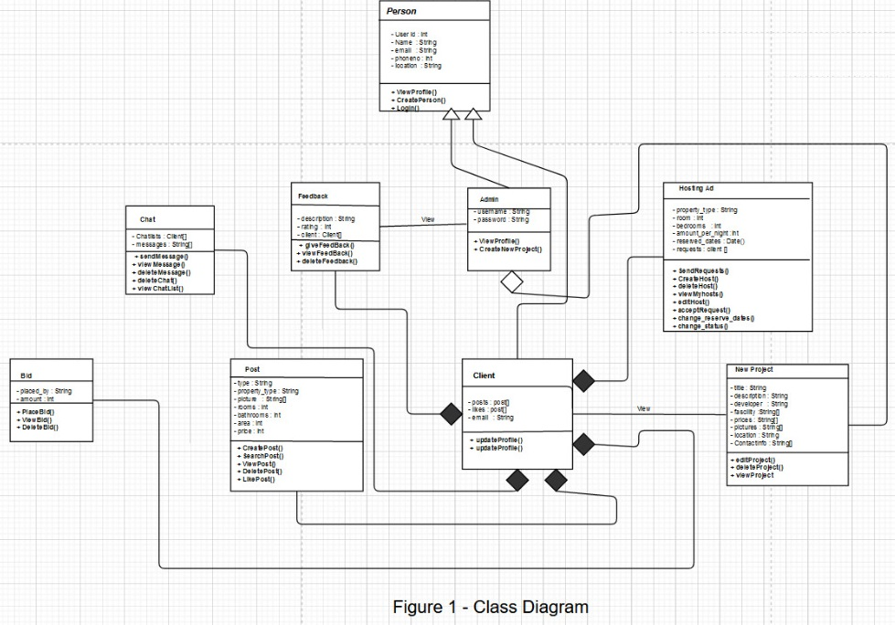

### Behavioral Diagrams

This section would present the behavior diagrams that show the dynamic behavior of the objects in a system, which can be described as a series of changes to the system over time.

#### Activity diagram

* + - User Profile Management

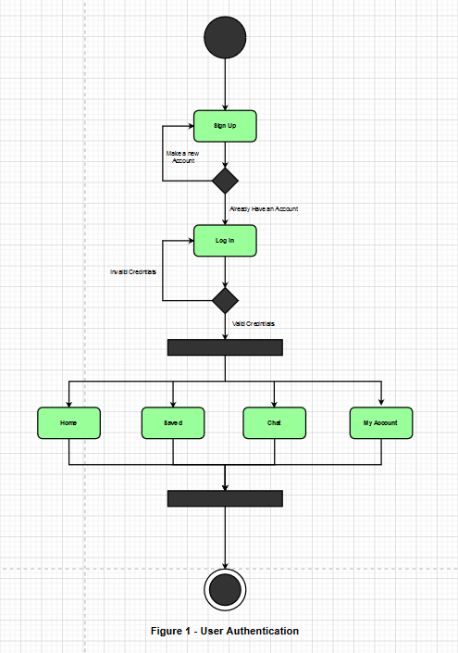

* + - Buy/Advertise

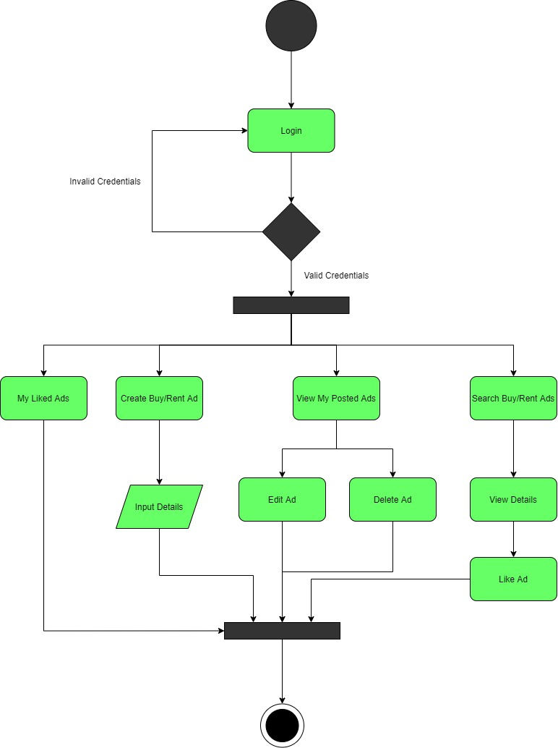

* + - Price Trends

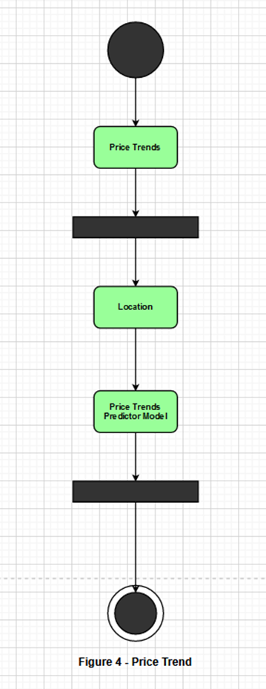

* + - Property Price Prediction

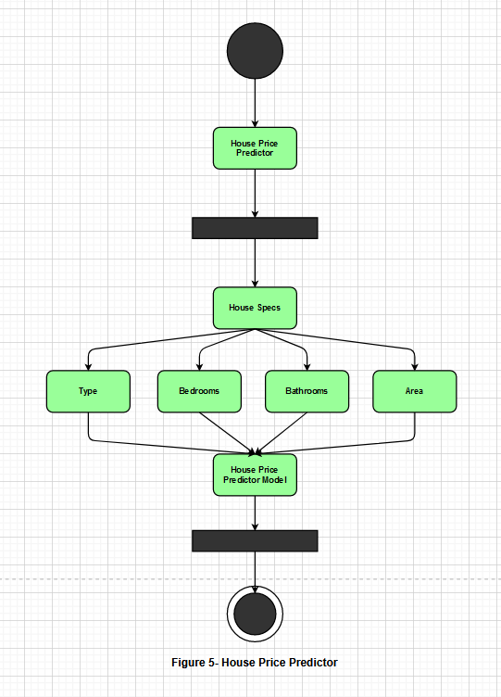

* + - New Projects

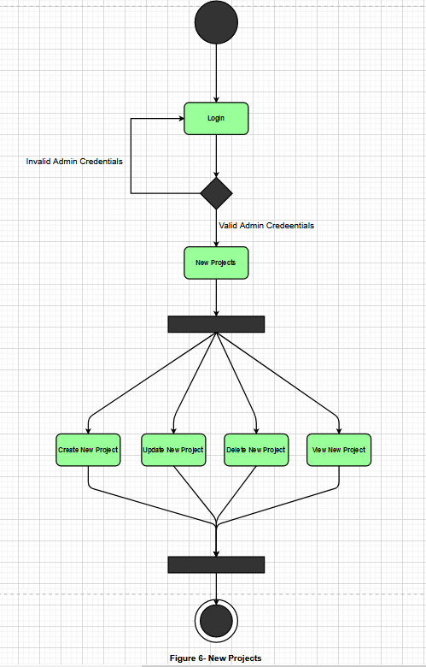

* + - Hosting

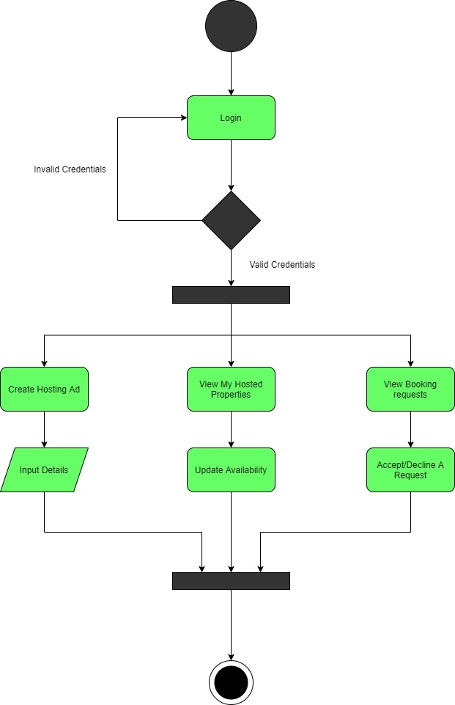

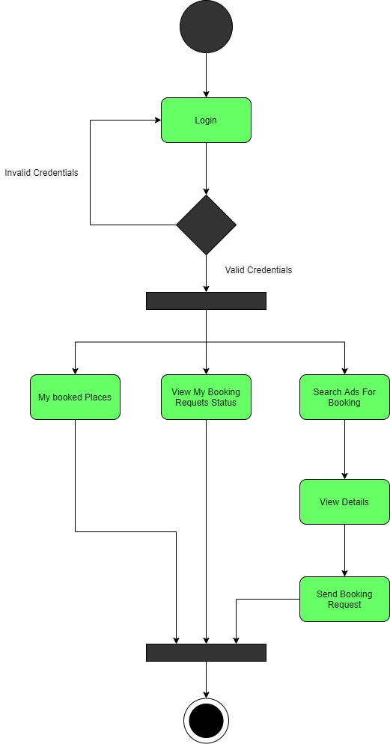

#### Sequence diagrams

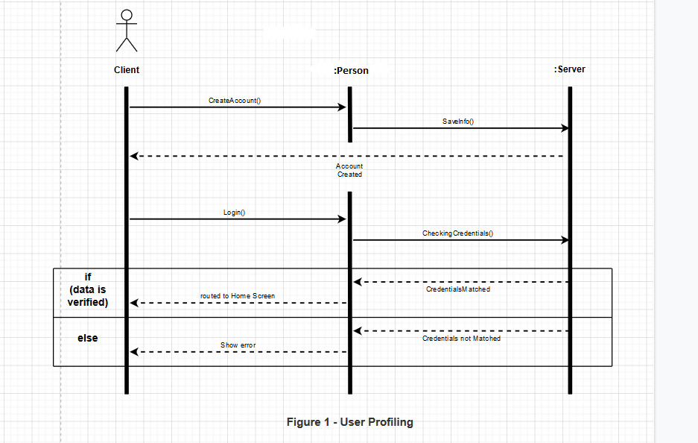

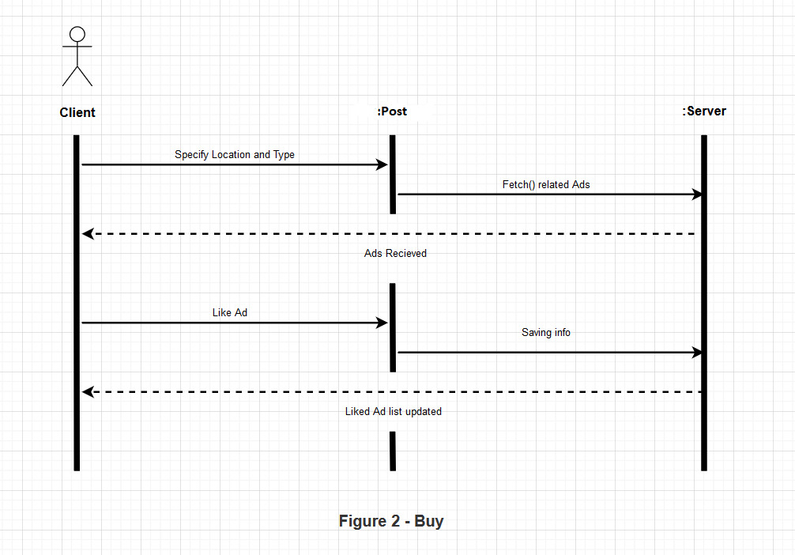

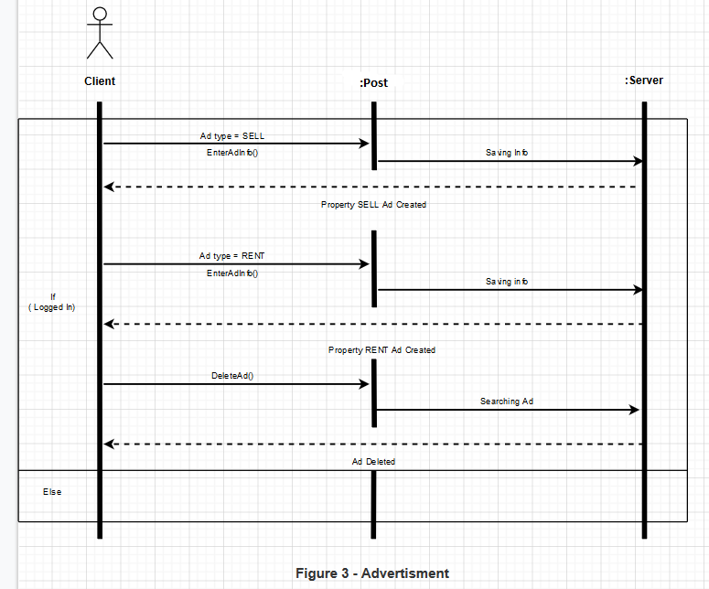

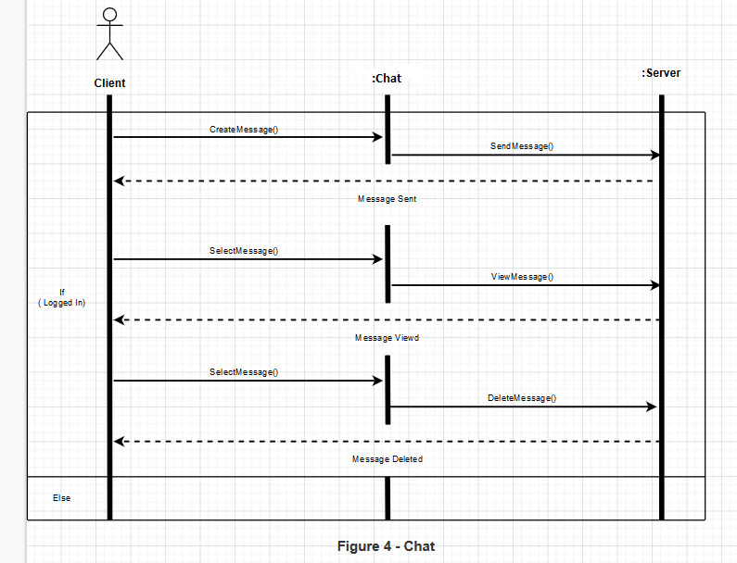

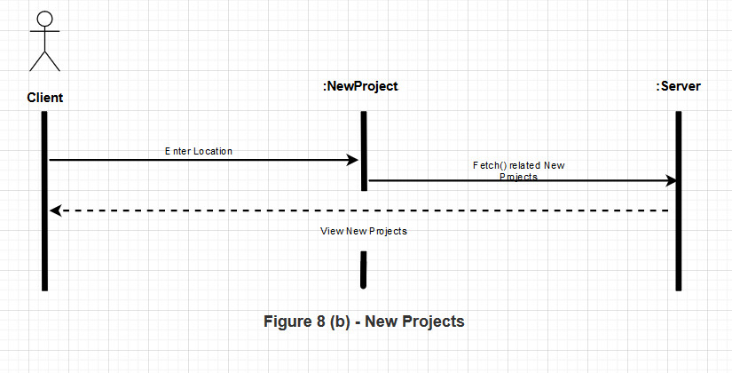

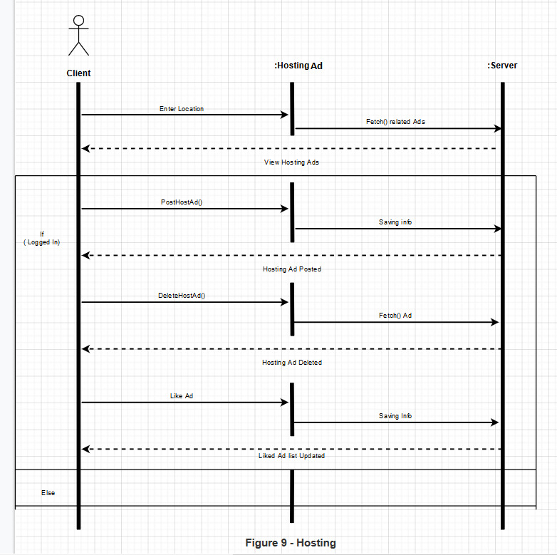

# Implementation



## Algorithm

Socket is used for instant live chatting between users, sendmessage() event is used when a user sends a text or picture message and it is sent to the socket server. Then from socket server, Sender ID and message text is sent to the client side getmessage() event.

## External APIs

**Table 5.1: Details of APIs used in the Project**

|  |  |  |  |
| --- | --- | --- | --- |
| **Name of API** | **Description of API** | **Purpose of Usage** | **List down the function/class name in which it is used** |
| Mapbox | To create a custom map | To show properties on a custom map | Property finder |

# Testing and Evaluation



## Manual Testing

### Unit Testing

.

**Unit Testing 1:** Login as User

**Testing Objective:** To ensure the login form is working correctly.

**Test Case Id:** BU_001

**Test Case Description:** Test the login functionality.

**Test Scenario:** Verify on entering valid email and password, then user can login.

**Table 6.1: Test Cases for Login**

|  |  |  |  |  |  |
| --- | --- | --- | --- | --- | --- |
| **No.** | **Test Case/Test Script** | **Test Data** | **Expected Result** | **Actual Result** | **Pass/Fail/Not Executed/ Suspended** |
| 1. | Verify user login after click on the ‘Login’ button on login form with correct input data | email:  Sharjeelnasir112@gmail.com  Password:  12345 | Successfully log into the main page of the system as FYP Committee member. | As Expected | Pass |

**Unit Testing 2:** User Sign up

**Testing Objective:** To ensure the Sign up user is working properly.

**Test Case Id:** BU_002

**Test Case Description:** Test the user Sign Up functionality.

**Test Scenario:**

**Table 6.2: Test Cases for User Sign Up**

|  |  |  |  |  |  |
| --- | --- | --- | --- | --- | --- |
| **No.** | **Test Case/Test Script** | **Test Data** | **Expected Result** | **Actual Result** | **Pass/Fail/Not Executed/ Suspended** |
| 1. | Verify user sign up after click on the ‘Sign up’ button on Register page. | Test Data:  Name: Ghazi Butt  Phone#: 03311567543  email: ghazibutt112@gmail.com password:12345  location: Islamabad | Successfully Registered User | As Expected | Pass |

**Unit Testing 3:** Logout

**Testing Objective:** To ensure the Logout is working properly.

**Test Case Id:** BU_003

**Test Case Description:** Test the logout functionality.

**Test Scenario:**

**Table 6.3: Test Cases for Logout**

|  |  |  |  |  |  |
| --- | --- | --- | --- | --- | --- |
| **No.** | **Test Case/Test Script** | **Test Data** | **Expected Result** | **Actual Result** | **Pass/Fail/Not Executed/ Suspended** |
| 1. | Verify user logout after click on the ‘Logout’ button on navbar submenu | Logged in user: sharjeelnasir112  @gmail.com | Successfully logged out | As Expected | Pass |

**Unit Testing 4:** View User List

**Testing Objective:** To ensure the View User List is working properly.

**Test Case Id:** BU_004

**Test Case Description:** Test the View User List functionality.

**Test Scenario:**

**Table 6.4: Test Cases for View User List**

|  |  |  |  |  |  |
| --- | --- | --- | --- | --- | --- |
| **No.** | **Test Case/Test Script** | **Test Data** | **Expected Result** | **Actual Result** | **Pass/Fail/Not Executed/ Suspended** |
| 1. | Verify correct listing shown when user list menu is opened | Test Data:  Users present in the database | Users listed | As Expected | Pass |

**Unit Testing 5:** Remove User

**Testing Objective:** To ensure the Remove User is working properly.

**Test Case Id:** BU_005

**Test Case Description:** Test the Remove User functionality.

**Test Scenario:**

**Table 6.5: Test Cases for Remove User**

|  |  |  |  |  |  |
| --- | --- | --- | --- | --- | --- |
| **No.** | **Test Case/Test Script** | **Test Data** | **Expected Result** | **Actual Result** | **Pass/Fail/Not Executed/ Suspended** |
| 1. | Verify User removal after clicking on the Remove user button | Test Data:  User: Sharjeelnasir112@gmail.com | User removed | As Expected | Pass |

**Unit Testing 6:** Add Property Sell/Rent Ad

**Testing Objective:** To ensure the Addition of property selling/renting ad is working properly.

**Test Case Id:** BU_006

**Test Case Description:** Test the Addition of Property Sell/Rent Ad functionality.

**Test Scenario:**

**Table 6.6: Test Cases for Add Property Sell/Rent Ad**

|  |  |  |  |  |  |
| --- | --- | --- | --- | --- | --- |
| **No.** | **Test Case/Test Script** | **Test Data** | **Expected Result** | **Actual Result** | **Pass/Fail/Not Executed/ Suspended** |
| 1. | Verify Property sell/rent Ad addition after clicking on the Add Property button | Test Data:  type: "sell"  property type:  "House"  portions:"3"  title:  "Beautiful house 3-story"  description: "Awesome house"  location:  "Rawalpindi"  area:  "10"  rooms:"8"  bathrooms:"5"  price:"30000000" | Sell/Rent Ad Added | As Expected | Pass |

**Unit Testing 7:** Upload Picture

**Testing Objective:** To ensure the uploading of picture is working properly.

**Test Case Id:** BU_007

**Test Case Description:** Test the uploading of picture functionality.

**Test Scenario:**

**Table 6.7: Test Cases for Add Picture**

|  |  |  |  |  |  |
| --- | --- | --- | --- | --- | --- |
| **No.** | **Test Case/Test Script** | **Test Data** | **Expected Result** | **Actual Result** | **Pass/Fail/Not Executed/ Suspended** |
| 1. | Verify the uploading of picture | Test Data:  picture: base64 string | Picture Uploaded | As Expected | Pass |

**Unit Testing 8:** Delete Property Ad

**Testing Objective:** To ensure the Delete Property Ad is working properly.

**Test Case Id:** BU_008

**Test Case Description:** Test the Delete Property Ad functionality.

**Test Scenario:**

**Table 6.8: Test Cases for Delete Property**

|  |  |  |  |  |  |
| --- | --- | --- | --- | --- | --- |
| **No.** | **Test Case/Test Script** | **Test Data** | **Expected Result** | **Actual Result** | **Pass/Fail/Not Executed/ Suspended** |
| 1. | Verify Property Ad removal after | Test Data:  Post id:  609d7d40a746003bcc5a49af | Property Deleted | As Expected | Pass |

**Unit Testing 9:** Filter Sell Ad

**Testing Objective:** To ensure the Filter Sell Ad is working properly.

**Test Case Id:** BU_009

**Test Case Description:** Test the Filter Sell Ad functionality.

**Test Scenario:**

**Table 6.9: Test Cases for Filter Sell Ad**

|  |  |  |  |  |  |
| --- | --- | --- | --- | --- | --- |
| **No.** | **Test Case/Test Script** | **Test Data** | **Expected Result** | **Actual Result** | **Pass/Fail/Not Executed/ Suspended** |
| 1. | Verify Filtering Sell Ads by selecting different options. | Test Data:  Property type:  “House”  Location:  “Rawalpindi” | Sell Ads Filtered | As Expected | Pass |

**Unit Testing 10:** Filter Rent Ad

**Testing Objective:** To ensure the Filter Rent Ad is working properly.

**Test Case Id:** BU_10

**Test Case Description:** Test the Filter Sell Ad functionality.

**Test Scenario:**

**Table 6.10: Test Cases for Filter Rent Ad**

|  |  |  |  |  |  |
| --- | --- | --- | --- | --- | --- |
| **No.** | **Test Case/Test Script** | **Test Data** | **Expected Result** | **Actual Result** | **Pass/Fail/Not Executed/ Suspended** |
| 1. | Verify Filtering Rent Ads by selecting different options. | Test Data:  Property type:  “House”  Location:  “Rawalpindi” | Rent Ads Filtered | As Expected | Pass |

**Unit Testing 11:** View Sell Ads List

**Testing Objective:** To ensure the Sell Ads list is working properly.

**Test Case Id:** BU_011

**Test Case Description:** Test the Sell ads list functionality.

**Test Scenario:**

**Table 6.11: Test Cases for Sell Ads list**

|  |  |  |  |  |  |
| --- | --- | --- | --- | --- | --- |
| **No.** | **Test Case/Test Script** | **Test Data** | **Expected Result** | **Actual Result** | **Pass/Fail/Not Executed/ Suspended** |
| 1. | Verify Sell ads list is viewed in the sell section | Test Data:  Sell Ads present in the database | Sell Ads viewed | As Expected | Pass |

**Unit Testing 12:** View Sell Ad

**Testing Objective:** To ensure the View Sell Ad is working properly.

**Test Case Id:** BU_012

**Test Case Description:** Test the View Sell ad functionality.

**Test Scenario:**

**Table 6.12: Test Cases for View Sell Ad**

|  |  |  |  |  |  |
| --- | --- | --- | --- | --- | --- |
| **No.** | **Test Case/Test Script** | **Test Data** | **Expected Result** | **Actual Result** | **Pass/Fail/Not Executed/ Suspended** |
| 1. | Verify Sell Ad is viewed. | Test Data:  Sell Ad present in the database | Sell Ad is viewed | As Expected | Pass |

**Unit Testing 13:** View Rent Ads List

**Testing Objective:** To ensure the Rent Ads list is working properly.

**Test Case Id:** BU_013

**Test Case Description:** Test the Rent ads list functionality.

**Test Scenario:**

**Table 6.13: Test Cases for Rent Ads list**

|  |  |  |  |  |  |
| --- | --- | --- | --- | --- | --- |
| **No.** | **Test Case/Test Script** | **Test Data** | **Expected Result** | **Actual Result** | **Pass/Fail/Not Executed/ Suspended** |
| 1. | Verify the Rent ads list is viewed in the rent section | Test Data:  Rent Ads present in the database | Rent Ads viewed | As Expected | Pass |

**Unit Testing 14:** View Rent Ad

**Testing Objective:** To ensure the View Rent Ad is working properly.

**Test Case Id:** BU_014

**Test Case Description:** Test the View Rent ad functionality.

**Test Scenario:**

**Table 6.14: Test Cases for View Rent Ad**

|  |  |  |  |  |  |
| --- | --- | --- | --- | --- | --- |
| **No.** | **Test Case/Test Script** | **Test Data** | **Expected Result** | **Actual Result** | **Pass/Fail/Not Executed/ Suspended** |
| 1. | Verify the Rent Ad is viewed | Test Data:  Rent Ad present in the database | Rent Ad viewed | As Expected | Pass |

**Unit Testing 15:** Add Property Location

**Testing Objective:** To ensure the Addition of property location is working properly.

**Test Case Id:** BU_0015

**Test Case Description:** Test the Addition of Property location functionality.

**Test Scenario:**

**Table 6.15: Test Cases for Add Property Location**

|  |  |  |  |  |  |
| --- | --- | --- | --- | --- | --- |
| **No.** | **Test Case/Test Script** | **Test Data** | **Expected Result** | **Actual Result** | **Pass/Fail/Not Executed/ Suspended** |
| 1. | Verify Property location addition | Test Data:  Latitude:53.322  Longitude:67.877 | Property Location Added | As Expected | Pass |

**Unit Testing 16:** View Properties on Map

**Testing Objective:** To ensure the View Properties on map is working properly.

**Test Case Id:** BU_016

**Test Case Description:** Test the View Properties on Map functionality.

**Test Scenario:**

**Table 6.16: Test Cases for View Properties on Map**

|  |  |  |  |  |  |
| --- | --- | --- | --- | --- | --- |
| **No.** | **Test Case/Test Script** | **Test Data** | **Expected Result** | **Actual Result** | **Pass/Fail/Not Executed/ Suspended** |
| 1. | Verify the Properties on map are viewed | Test Data:  Properties Location present in the database | Properties on map viewed | As Expected | Pass |

**Unit Testing 17:** Filter Map

**Testing Objective:** To ensure the Map Filter is working properly.

**Test Case Id:** BU_17

**Test Case Description:** Test the Filter Map functionality.

**Test Scenario:**

**Table 6.17: Test Cases for Filter Map**

|  |  |  |  |  |  |
| --- | --- | --- | --- | --- | --- |
| **No.** | **Test Case/Test Script** | **Test Data** | **Expected Result** | **Actual Result** | **Pass/Fail/Not Executed/ Suspended** |
| 1. | Verify Filtering Map by selecting different options. | Test Data:  Property type:  “House”  Location:  “Rawalpindi” | Map Filtered | As Expected | Pass |

**Unit Testing 18:** Add Property Price Prediction Info

**Testing Objective:** To ensure the Addition of property Price Prediction Info is working properly.

**Test Case Id:** BU_0018

**Test Case Description:** Test the Addition of Property Price Prediction Info functionality.

**Test Scenario:**

**Table 6.18: Test Cases for Add Property Price Prediction Info**

|  |  |  |  |  |  |
| --- | --- | --- | --- | --- | --- |
| **No.** | **Test Case/Test Script** | **Test Data** | **Expected Result** | **Actual Result** | **Pass/Fail/Not Executed/ Suspended** |
| 1. | Verify Property Price Prediction Info addition | Test Data:  Property type:  “House”  Rooms:6  Bathrooms:3  Location:  “Rawalpindi” | Property Price Prediction Info Added | As Expected | Pass |

**Unit Testing 19:** View Property Predicted Price

**Testing Objective:** To ensure the View Property Predicted Price is working properly.

**Test Case Id:** BU_019

**Test Case Description:** Test the View Predicted Price functionality.

**Test Scenario:**

**Table 6.19: Test Cases for View Property Predicted Price**

|  |  |  |  |  |  |
| --- | --- | --- | --- | --- | --- |
| **No.** | **Test Case/Test Script** | **Test Data** | **Expected Result** | **Actual Result** | **Pass/Fail/Not Executed/ Suspended** |
| 1. | Verify the Predicted Price of a property is viewed | Test Data:  Property Price Predicted in the backend | Property Price viewed | As Expected | Pass |

**Unit Testing 20:** Add Hosting Property Ad

**Testing Objective:** To ensure the Addition of Hosting Property ad is working properly.

**Test Case Id:** BU_020

**Test Case Description:** Test the Addition of Hosting Property Ad functionality.

**Test Scenario:**

**Table 6.20: Test Cases for Add Hosting Property Ad**

|  |  |  |  |  |  |
| --- | --- | --- | --- | --- | --- |
| **No.** | **Test Case/Test Script** | **Test Data** | **Expected Result** | **Actual Result** | **Pass/Fail/Not Executed/ Suspended** |
| 1. | Verify Hosting Property Ad addition after clicking on the Add Property button | Test Data:  title:  "Beautiful house 3-story"  description: "Awesome house"  location:  "Rawalpindi"  area:  "10"  rooms:"8"  bathrooms:"5"  price per night:"6000" | Hosting Property Ad Added | As Expected | Pass |

**Unit Testing 21:** Filter Stay Places

**Testing Objective:** To ensure the Filter Stay Places is working properly.

**Test Case Id:** BU_021

**Test Case Description:** Test the Filter S Stay Places functionality.

**Test Scenario:**

**Table 6.21: Test Cases for Filter Stay Places**

|  |  |  |  |  |  |
| --- | --- | --- | --- | --- | --- |
| **No.** | **Test Case/Test Script** | **Test Data** | **Expected Result** | **Actual Result** | **Pass/Fail/Not Executed/ Suspended** |
| 1. | Verify Filtering Stay Places by selecting different options. | Test Data:  Dates:  [24-05-2021,25-05-2021]  Location:  “Rawalpindi” | Stay Places Filtered | As Expected | Pass |

**Unit Testing 22:** View Places for Stay List

**Testing Objective:** To ensure the Places for Stay list is working properly.

**Test Case Id:** BU_022

**Test Case Description:** Test the Places for Stay list functionality.

**Test Scenario:**

**Table 6.22: Test Cases for Places for Stay list**

|  |  |  |  |  |  |
| --- | --- | --- | --- | --- | --- |
| **No.** | **Test Case/Test Script** | **Test Data** | **Expected Result** | **Actual Result** | **Pass/Fail/Not Executed/ Suspended** |
| 1. | Verify Places for Stay list is viewed in the sell section | Test Data:  Places for Stay Ads present in the database | Places for Stay viewed | As Expected | Pass |

**Unit Testing 23:** View Property Stay Ad

**Testing Objective:** To ensure the View Property Stay Ad is working properly.

**Test Case Id:** BU_023

**Test Case Description:** Test the View Property Stay ad functionality.

**Test Scenario:**

**Table 6.23: Test Cases for View Property Stay Ad**

|  |  |  |  |  |  |
| --- | --- | --- | --- | --- | --- |
| **No.** | **Test Case/Test Script** | **Test Data** | **Expected Result** | **Actual Result** | **Pass/Fail/Not Executed/ Suspended** |
| 1. | Verify Property Stay Ad is viewed. | Test Data:  Property Stay Ad present in the database | Property Stay is viewed | As Expected | Pass |

**Unit Testing 24:** Add Reservation

**Testing Objective:** To ensure the Add Reservation is working properly.

**Test Case Id:** BU_024

**Test Case Description:** Test the Add Reservation functionality.

**Test Scenario:**

**Table 6.24: Test Cases for Add Reservation**

|  |  |  |  |  |  |
| --- | --- | --- | --- | --- | --- |
| **No.** | **Test Case/Test Script** | **Test Data** | **Expected Result** | **Actual Result** | **Pass/Fail/Not Executed/ Suspended** |
| 1. | Verify reservation is added. | Test Data:  Dates:  [24-05-2021,25-05-2021] | Reservation is added | As Expected | Pass |

**Unit Testing 25:** Accept Reservation

**Testing Objective:** To ensure the Accept Reservation is working properly.

**Test Case Id:** BU_025

**Test Case Description:** Test the Accept Reservation functionality.

**Test Scenario:**

**Table 6.25: Test Cases for Accept Reservation**

|  |  |  |  |  |  |
| --- | --- | --- | --- | --- | --- |
| **No.** | **Test Case/Test Script** | **Test Data** | **Expected Result** | **Actual Result** | **Pass/Fail/Not Executed/ Suspended** |
| 1. | Verify reservation is accepted. | Test Data:  Dates:  [24-05-2021,25-05-2021] | Reservation is accepted | As Expected | Pass |

**Unit Testing 26:** Decline Reservation

**Testing Objective:** To ensure the Decline Reservation is working properly.

**Test Case Id:** BU_026

**Test Case Description:** Test the Decline Reservation functionality.

**Test Scenario:**

**Table 6.26: Test Cases for Decline Reservation**

|  |  |  |  |  |  |
| --- | --- | --- | --- | --- | --- |
| **No.** | **Test Case/Test Script** | **Test Data** | **Expected Result** | **Actual Result** | **Pass/Fail/Not Executed/ Suspended** |
| 1. | Verify reservation is declined. | Test Data:  Dates:  [24-05-2021,25-05-2021] | Reservation is declined | As Expected | Pass |

**Unit Testing 27:** View Reservations

**Testing Objective:** To ensure the View Reservations is working properly.

**Test Case Id:** BU_027

**Test Case Description:** Test the View Reservations functionality.

**Test Scenario:**

**Table 6.27: Test Cases for View Reservations**

|  |  |  |  |  |  |
| --- | --- | --- | --- | --- | --- |
| **No.** | **Test Case/Test Script** | **Test Data** | **Expected Result** | **Actual Result** | **Pass/Fail/Not Executed/ Suspended** |
| 1. | Verify Reservation are viewed. | Test Data:  Reservations present in the database | Reservations viewed | As Expected | Pass |

**Unit Testing 28:** Add Conversation

**Testing Objective:** To ensure the Add Conversation is working properly.

**Test Case Id:** BU_028

**Test Case Description:** Test the Add Conversation functionality.

**Test Scenario:**

**Table 6.28: Test Cases for Add Conversation**

|  |  |  |  |  |  |
| --- | --- | --- | --- | --- | --- |
| **No.** | **Test Case/Test Script** | **Test Data** | **Expected Result** | **Actual Result** | **Pass/Fail/Not Executed/ Suspended** |
| 1. | Verify Conversation is added. | Test Data:  members:[id, id]  title: Beautiful house for sale | Conversation added | As Expected | Pass |

**Unit Testing 29:** View Conversation

**Testing Objective:** To ensure the View Conversation is working properly.

**Test Case Id:** BU_029

**Test Case Description:** Test the View Conversation functionality.

**Test Scenario:**

**Table 6.29: Test Cases for View Conversation**

|  |  |  |  |  |  |
| --- | --- | --- | --- | --- | --- |
| **No.** | **Test Case/Test Script** | **Test Data** | **Expected Result** | **Actual Result** | **Pass/Fail/Not Executed/ Suspended** |
| 1. | Verify Conversation are viewed. | Test Data:  Conversations present in the database | Conversations viewed | As Expected | Pass |

**Unit Testing 30:** Send Message

**Testing Objective:** To ensure the Send Message is working properly.

**Test Case Id:** BU_30

**Test Case Description:** Test the Send Message functionality.

**Test Scenario:**

**Table 6.30: Test Cases for Send Message**

|  |  |  |  |  |  |
| --- | --- | --- | --- | --- | --- |
| **No.** | **Test Case/Test Script** | **Test Data** | **Expected Result** | **Actual Result** | **Pass/Fail/Not Executed/ Suspended** |
| 1. | Verify Message is sent | Test Data:  Sender Id: id  Text: Hello | Message sent | As Expected | Pass |

**Unit Testing 31:** View Message

**Testing Objective:** To ensure the View Message is working properly.

**Test Case Id:** BU_031

**Test Case Description:** Test the View Message functionality.

**Test Scenario:**

**Table 6.31: Test Cases for View Message**

|  |  |  |  |  |  |
| --- | --- | --- | --- | --- | --- |
| **No.** | **Test Case/Test Script** | **Test Data** | **Expected Result** | **Actual Result** | **Pass/Fail/Not Executed/ Suspended** |
| 1. | Verify Message. | Test Data:  Message present in the database | Message viewed | As Expected | Pass |

### Functional Testing

**Functional Testing 1:** Login with different roles

**Test Objective**: To ensure that the correct page with the correct navigation bar is loaded.

**Test Case Id:** FT_001

**Test Case Description:** Test Signin for Users

**Test Scenario:** Verify thatuseris logged in successfully

**Table 6.32: Test Cases for Login with different Roles**

|  |  |  |  |  |  |
| --- | --- | --- | --- | --- | --- |
| **No.** | **Test Case/Test Script** | **Test Data** | **Expected Result** | **Actual Result** | **Pass/Fail/Not Executed/ Suspended** |
| 1. | Login as any role by providing correct input and then clicking Login button | URL: <http://localhost:3000/user/login> body: user object | Main page for the user is loaded according to their role | Login as any role user | Pass |

**Functional Testing 2:** User Signup

**Test Objective**: To ensure that the user is registered

**Test Case Id:** FT_002

**Test Case Description:** Test registering user

**Test Scenario:** Verify thatuseris register successfully

**Table 6.33: Test Cases for Registering User**

|  |  |  |  |  |  |
| --- | --- | --- | --- | --- | --- |
| **No.** | **Test Case/Test Script** | **Test Data** | **Expected Result** | **Actual Result** | **Pass/Fail/Not Executed/ Suspended** |
| 1. | Add User providing required input and clicking Add button | URL: http://localhost:3000/user/signup  body: user object | User is added to database | User Added Successfully | Pass |

**Functional Testing 3:** Delete User

**Test Objective**: To ensure that the user is removed

**Test Case Id:** FT_003

**Test Case Description:** Test deleting user

**Test Scenario:** Verify thatuseris deleted successfully

**Table 6.34: Test Cases for Deleting User**

|  |  |  |  |  |  |
| --- | --- | --- | --- | --- | --- |
| **No.** | **Test Case/Test Script** | **Test Data** | **Expected Result** | **Actual Result** | **Pass/Fail/Not Executed/ Suspended** |
| 1. | Delete user by visiting url | URL: <http://localhost:3000/user/remove/:id> | User is removed from database | User Removed Successfully | Pass |

**Functional Testing 4:** View All Users

**Test Objective**: To ensure that the user is listed

**Test Case Id:** FT_004

**Test Case Description:** Test user listing

**Test Scenario:** Verify thatusersare listed successfully

**Table 6.35: Test Cases for Viewing Users**

|  |  |  |  |  |  |
| --- | --- | --- | --- | --- | --- |
| **No.** | **Test Case/Test Script** | **Test Data** | **Expected Result** | **Actual Result** | **Pass/Fail/Not Executed/ Suspended** |
| 1. | View Users by visiting url | URL: http://localhost:3000/user/all | Users list is shown | Users listed Successfully | Pass |

**Functional Testing 5:** Add Sell/Rent Ad

**Test Objective**: To ensure that the Ad is added

**Test Case Id:** FT_005

**Test Case Description:** Test adding an Ad

**Test Scenario:** Verify thatAdis added successfully

**Table 6.36: Test Cases for Adding Ad**

|  |  |  |  |  |  |
| --- | --- | --- | --- | --- | --- |
| **No.** | **Test Case/Test Script** | **Test Data** | **Expected Result** | **Actual Result** | **Pass/Fail/Not Executed/ Suspended** |
| 1. | Add Ad providing required input and clicking Add button | URL: http://localhost:3000/post/postad  body: Ad object | Post is added to database | Post Added Successfully | Pass |

**Functional Testing 6:** View Buy/Rent Ads List

**Test Objective**: To ensure that the Ads list is viewed

**Test Case Id:** FT_006

**Test Case Description:** Test viewing Ads List

**Test Scenario:** Verify thatAds Listis viewed successfully

**Table 6.37: Test Cases for Viewing Ads List**

|  |  |  |  |  |  |
| --- | --- | --- | --- | --- | --- |
| **No.** | **Test Case/Test Script** | **Test Data** | **Expected Result** | **Actual Result** | **Pass/Fail/Not Executed/ Suspended** |
| 1. | View Ads list by clicking buy sections | URL: http://localhost:3000/post/ /displayads/:location/:propertytype/:type | Ads List is viewed | Ads List viewed Successfully | Pass |

**Functional Testing 7:** View Buy/Rent Ad

**Test Objective**: To ensure that the Ad is viewed

**Test Case Id:** FT_007

**Test Case Description:** Test viewing Ad

**Test Scenario:** Verify thatAd is viewed successfully

**Table 6.38: Test Cases for Viewing Ad**

|  |  |  |  |  |  |
| --- | --- | --- | --- | --- | --- |
| **No.** | **Test Case/Test Script** | **Test Data** | **Expected Result** | **Actual Result** | **Pass/Fail/Not Executed/ Suspended** |
| 1. | View Ad by clicking an Ad. | URL: http://localhost:3000/post/ /viewpost/:id | Ad is viewed | Ad is viewed Successfully | Pass |

**Functional Testing 8:** Create Conversation

**Test Objective**: To ensure that the conversation is created

**Test Case Id:** FT_008

**Test Case Description:** Test creation of conversation

**Test Scenario:** Verify thatconversation is created successfully

**Table 6.39: Test Cases for Creating Conversation**

|  |  |  |  |  |  |
| --- | --- | --- | --- | --- | --- |
| **No.** | **Test Case/Test Script** | **Test Data** | **Expected Result** | **Actual Result** | **Pass/Fail/Not Executed/ Suspended** |
| 1. | Create a Conversation | URL: http://localhost:3000/conversation/  body: conversation object | Conversation is added to database | Conversation Added Successfully | Pass |

**Functional Testing 9:** View Conversations List

**Test Objective**: To ensure that the Conversations list is viewed

**Test Case Id:** FT_009

**Test Case Description:** Test viewing Conversations List

**Test Scenario:** Verify thatConversations Listis viewed successfully

**Table 6.40: Test Cases for Viewing Conversations List**

|  |  |  |  |  |  |
| --- | --- | --- | --- | --- | --- |
| **No.** | **Test Case/Test Script** | **Test Data** | **Expected Result** | **Actual Result** | **Pass/Fail/Not Executed/ Suspended** |
| 1. | View Conversations list by clicking messenger sections | URL: http://localhost:3000/conversation/:userId | Conversations List is viewed | Conversations List viewed Successfully | Pass |

**Functional Testing 10:** Add Message

**Test Objective**: To ensure that the message is added

**Test Case Id:** FT_010

**Test Case Description:** Test adding message

**Test Scenario:** Verify thatmessageis added successfully

**Table 6.41: Test Cases for Adding Ad**

|  |  |  |  |  |  |
| --- | --- | --- | --- | --- | --- |
| **No.** | **Test Case/Test Script** | **Test Data** | **Expected Result** | **Actual Result** | **Pass/Fail/Not Executed/ Suspended** |
| 1. | Add message input and click on send. | URL: http://localhost:3000/message/  body: message object | Message is added to database | Message Added Successfully | Pass |

**Functional Testing 11:** Send Message

**Test Objective**: To ensure that the message is sent

**Test Case Id:** FT_011

**Test Case Description:** Test message sending

**Test Scenario:** Verify thatmessage is sent successfully

**Table 6.42: Test Cases for Sending Message**

|  |  |  |  |  |  |
| --- | --- | --- | --- | --- | --- |
| **No.** | **Test Case/Test Script** | **Test Data** | **Expected Result** | **Actual Result** | **Pass/Fail/Not Executed/ Suspended** |
| 1. | Type message and send by pressing Enter | Socket: Message Text, sender Id, Receiver Id and post id | Message sent | Message sent successfully | Pass |

**Functional Testing 12:** View Messages

**Test Objective**: To ensure that the Messages are viewed

**Test Case Id:** FT_012

**Test Case Description:** Test viewing Messages

**Test Scenario:** Verify thatMessages are viewed successfully

**Table 6.43: Test Cases for Viewing Conversations List**

|  |  |  |  |  |  |
| --- | --- | --- | --- | --- | --- |
| **No.** | **Test Case/Test Script** | **Test Data** | **Expected Result** | **Actual Result** | **Pass/Fail/Not Executed/ Suspended** |
| 1. | View Messages by clicking on conversation | URL: <http://localhost:3000/message/:conversationId> | Messages are viewed | Messages viewed Successfully | Pass |

**Functional Testing 13:** Add Hosting Ad

**Test Objective**: To ensure that the Hosting Ad is added

**Test Case Id:** FT_013

**Test Case Description:** Test adding an Hosting Ad

**Test Scenario:** Verify that HostingAdis added successfully

**Table 6.44: Test Cases for Add Hosting Ad**

|  |  |  |  |  |  |
| --- | --- | --- | --- | --- | --- |
| **No.** | **Test Case/Test Script** | **Test Data** | **Expected Result** | **Actual Result** | **Pass/Fail/Not Executed/ Suspended** |
| 1. | Add Hosting Ad by providing required input | URL: http://localhost:3000/host/posthostingad  body: Hosting Ad object | Hosting Ad is added to database | Hosting Ad Added Successfully | Pass |

**Functional Testing 14:** View Hosting Ads List

**Test Objective**: To ensure that the Hosting Ads list is viewed

**Test Case Id:** FT_014

**Test Case Description:** Test viewing Hosting Ads List

**Test Scenario:** Verify that HostingAds Listis viewed successfully

**Table 6.45: Test Cases for Viewing Hosting Ads List**

|  |  |  |  |  |  |
| --- | --- | --- | --- | --- | --- |
| **No.** | **Test Case/Test Script** | **Test Data** | **Expected Result** | **Actual Result** | **Pass/Fail/Not Executed/ Suspended** |
| 1. | View Hosting Ads list by clicking sections | URL: http://localhost:3000/host/ /displayhostings/:dates/:location | Hosting Ads List is viewed | Hosting Ads List viewed Successfully | Pass |

**Functional Testing 15:** View Hosting Ad

**Test Objective**: To ensure that the Hosting Ad is viewed

**Test Case Id:** FT_015

**Test Case Description:** Test viewing Hosting Ad

**Test Scenario:** Verify that HostingAdis viewed successfully

**Table 6.46: Test Cases for Viewing Hosting Ad**

|  |  |  |  |  |  |
| --- | --- | --- | --- | --- | --- |
| **No.** | **Test Case/Test Script** | **Test Data** | **Expected Result** | **Actual Result** | **Pass/Fail/Not Executed/ Suspended** |
| 1. | View Hosting Ad by clicking Hosting Ad | URL: http://localhost:3000/host/ /viewhosting/:id | Hosting Ad is viewed | Hosting Ad viewed Successfully | Pass |

**Functional Testing 16:** Send Reservation

**Test Objective**: To ensure that the reservation is sent

**Test Case Id:** FT_016

**Test Case Description:** Test sending an reservation

**Test Scenario:** Verify that reservation is sent successfully

**Table 6.47: Test Cases for Sending Reservation**

|  |  |  |  |  |  |
| --- | --- | --- | --- | --- | --- |
| **No.** | **Test Case/Test Script** | **Test Data** | **Expected Result** | **Actual Result** | **Pass/Fail/Not Executed/ Suspended** |
| 1. | Send Reservation on hosting ad | URL: http://localhost:3000/host/addreservation  body: Hosting Ad object | Reservation is added to database | Reservation is Added Successfully | Pass |

**Functional Testing 17:** Accept Reservation

**Test Objective**: To ensure that the reservation is accepted

**Test Case Id:** FT_017

**Test Case Description:** Test reservation is accepted

**Test Scenario:** Verify that reservation is accepted successfully

**Table 6.48: Test Cases for Accepting Reservation**

|  |  |  |  |  |  |
| --- | --- | --- | --- | --- | --- |
| **No.** | **Test Case/Test Script** | **Test Data** | **Expected Result** | **Actual Result** | **Pass/Fail/Not Executed/ Suspended** |
| 1. | Accept Reservation on hosting ad | URL: http://localhost:3000/host/acceptreservation  body: Hosting Ad object | Reservation is accepted | Reservation is Accepted Successfully | Pass |

**Functional Testing 17:** Cancel Reservation

**Test Objective**: To ensure that the reservation is cancelled

**Test Case Id:** FT_017

**Test Case Description:** Test reservation is cancelled

**Test Scenario:** Verify that reservation is cancelled successfully

**Table 6.49: Test Cases for Cancelling Reservation**

|  |  |  |  |  |  |
| --- | --- | --- | --- | --- | --- |
| **No.** | **Test Case/Test Script** | **Test Data** | **Expected Result** | **Actual Result** | **Pass/Fail/Not Executed/ Suspended** |
| 1. | Cancel Reservation on hosting ad | URL: http://localhost:3000/host/canceltreservation  body: Hosting Ad object | Reservation is cancelled | Reservation is cancelled Successfully | Pass |

**Functional Testing 18:** Add New Project

**Test Objective**: To ensure that the New Project is added

**Test Case Id:** FT_018

**Test Case Description:** Test adding an New Project

**Test Scenario:** Verify that New Projectis added successfully

**Table 6.50: Test Cases for Add New Project**

|  |  |  |  |  |  |
| --- | --- | --- | --- | --- | --- |
| **No.** | **Test Case/Test Script** | **Test Data** | **Expected Result** | **Actual Result** | **Pass/Fail/Not Executed/ Suspended** |
| 1. | Add New Project by providing required input | URL: http://localhost:3000/project/add  body: Hosting Ad object | New Project is added to database | New Project is Added Successfully | Pass |

**Functional Testing 19:** View New Projects List

**Test Objective**: To ensure that the New Projects list is viewed

**Test Case Id:** FT_019

**Test Case Description:** Test viewing New Projects List

**Test Scenario:** Verify that New Projects Listis viewed successfully

**Table 6.51: Test Cases for Viewing Hosting Ads List**

|  |  |  |  |  |  |
| --- | --- | --- | --- | --- | --- |
| **No.** | **Test Case/Test Script** | **Test Data** | **Expected Result** | **Actual Result** | **Pass/Fail/Not Executed/ Suspended** |
| 1. | View New Projects list by clicking sections | URL: http://localhost:3000/project/view | New Projects List is viewed | New Projects List viewed Successfully | Pass |

**Functional Testing 20:** View New Project

**Test Objective**: To ensure that the New Project is viewed

**Test Case Id:** FT_020

**Test Case Description:** Test viewing New Project

**Test Scenario:** Verify that New Projectis viewed successfully

**Table 6.52: Test Cases for Viewing New Project**

|  |  |  |  |  |  |
| --- | --- | --- | --- | --- | --- |
| **No.** | **Test Case/Test Script** | **Test Data** | **Expected Result** | **Actual Result** | **Pass/Fail/Not Executed/ Suspended** |
| 1. | View New Project by clicking New Project | URL: http://localhost:3000/project/ /view/:id | New Project is viewed | New Project viewed Successfully | Pass |

### Integration Testing

We have used the big bang approach in integration testing because unit and functional testing was done in great detail for individual modules and then all the separated modules were integrated together, and we performed Big Bang integration testing.

**Table 6.53: Test Cases for Integration Testing**

|  |  |  |  |  |  |
| --- | --- | --- | --- | --- | --- |
| **No.** | **Test Case/Test Script** | **Test Data** | **Expected Result** | **Actual Result** | **Pass/Fail/Not Executed/ Suspended** |
| 1. | Admin signs in and navigate to all the Admin functionalities. | Username: admin  Password: 123 | Login successful, admin portal is shown and admin successfully navigate to all possible admin functionalities. | As Expected | Pass |
| 2. | User signs in and navigate to all the User functionalities. | Username;  Sharjeelnasir112@gmail.com  Password: 12345 | Login successful, user portal is shown and is navigated to all possible functionalities | As expected | Pass |

|  |  |  |  |  |  |
| --- | --- | --- | --- | --- | --- |
|  |  |  |  |  |  |

### System Testing

After successfully completing the unit testing, functional testing and integration testing, system testing was performed against the requirements of the system as mentioned in Scope, SDS and SRS chapters, to ensure that all the functionalities of the system are working correctly to meet the requirements. The requirements include both FRs and NFRs. Apart from that, all the screens, buttons and interfaces etc. were also tested such that they provide a good UI/UX. Hence, in short, the whole system was tested successfully to ensure a properly working Estate Wizards Web Application.

# Conclusion and Future Work

This chapter concludes the project and highlights future work.



## Conclusion

This Project effectively solves the problem of not having a single platform where they can go if they need anything related to property and real-estate dealing. Whether it be buying, selling, renting or even hosting a spare place for travelers. Or maybe just to get an idea of the prices of a certain area or their own properties. Estate Wizards provides a single platform to have access to all of these feature at one place.

## Future Work

Future Work will involve the integration of payment methods so that user can pay or receive money for the buying/selling of their properties.

# References

* 1. Linear Regression Analysis study

(<https://www.researchgate.net/publication/324944461_Linear_regression_analysis_study> )